

CSIT321 Capstone Project
SOVA Final Report
Luminara (Group 4)
Aagna Samhita (8448401)
Anelle Khare (8409079)
Samia Khan (8303952)
Sandra Jose (8551236)
Sanura Castellino (8367358)
Sara Hayel (8033924)
Sofia Francisco (8123688)

Table of Contents
Table of Contents 2
List of Tables 5
List of Figures 6
Executive Summary 7
Introduction 7
Problem Statement 7
Objectives 8
Background & Related Work 8
Competitors Analysis 9
Planning & Feasibility 10
Target Users & Stakeholders 10
Target Users 10
Stakeholder Analysis 11
RACI Matrix 11
Scope 12
In Scope 12
Out of Scope 13
Feasibility Analysis 13
Technical Feasibility 13
Software Feasibility 14
Legal Feasibility 14
Operational Feasibility 15
Risk Assessment & Mitigation 15
Methodology 16
Development Approach 16
Phase-Wise Deliverables 16
Project Management Tools 17
Project Timeline 17
Milestones 17
Timeline Summary 18
Team Responsibilities 19
System Requirements 20
Business Context 20
System Features & Data Flow 21
Computer Vision Non-Verbal Cues Detection 21
Audio Capture & Transcription 23
Sentiment Analysis & Processing 24
Multilingual Translation Support 25
LLM Description Generation 26
Text-to-Speech Feedback 27
Desktop App Dashboard 28
Google Meet Chrome Extension 29
Functional Requirements 30
Non-Functional Requirements 31
Data Requirements 31
Interface Requirements 32
Performance Requirements 33
Security Requirements 34
Operational Requirements 34
Legal & Political Requirements 35
Software & Hardware Requirements 35
Constraints & Open Issues 36
Preliminary Budget 37
System Design 38
System Overview 38
System Architecture 39
High-Level Architecture 39
Component Decomposition 41
Design Rationale 41
High-Level Process Flow 42
Data Design 43
Data Description 43
Data Dictionary 44
Component Design 47
Expression Detection 47
Gesture Detection 48
Body Action Detection 48
Audio Capture & Transcription 49
Processor 49
NLP & Sentiment Analysis Engine 49
TTS Engine 50
WebSockets Connection 50
Desktop Application 50
Chrome Extension 51
Interface Design 51
Overview 51
Figma Mockups 53
Screen Objects & Actions 56
Requirements Traceability Matrix 57
Implementation 59
Development Environment & Tools 59
Module Implementation 60
Vision Pipeline 60
Audio & Transcription Pipeline 61
NLP, Sentiment Analysis, & Processing 61
LLM Integration 61
TTS & Translation Engine 62
WebSocket Communication Layer 62
Desktop App, Chrome Extension, & Overlay 62
Key Implementation Decisions & Challenges 62
Deviations from Original Design 63
Testing 64
Test Methodology 64
Negative Testing 64
Functional Testing 64
Non-Functional Testing 65
Test Environment 65
Entry & Exit Criteria 66
Entry Criteria 66
Exit Criteria 66
Test Results 66
Negative Testing 66
Functional Test Cases 69
Non-Functional Test Cases 78
Edge Test Cases 85
Defects & Resolutions 87
Product Demonstration 88
Desktop Application Dashboard 88
Chrome Extension Popup 90
Google Meet Overlay 91
Conclusion 91
Summary of Work 91
Objectives Revisited 91
Limitations 92
Future Improvements & Long-Term Vision 92
References 92
Appendices 94
Appendix A: Glossary 94
Appendix B: Github 95
Appendix C: Deliverables Links 96
Appendix D: Preliminary & Final Figma Prototypes 96
Appendix E: Report Work Distribution 96

List of Tables
Table 1: Competitors analysis 9
Table 2: Stakeholders, roles, needs, and engagement 11
Table 3: Additional stakeholders and business impact 11
Table 4: RACI Matrix 11
Table 5: In-scope features 12
Table 6: Technology stack 14
Table 7: Risks, likelihood, and impact 15
Table 8: Project deliverables 16
Table 9: Project management tools used 17
Table 10: Project milestones 17
Table 11: Development timeline 18
Table 12: Project team responsibilities 19
Table 13: Non-functional requirements 31
Table 14: Data requirements 31
Table 15: Interface requirements 32
Table 16: Performance requirements 33
Table 17: Security requirements 34
Table 18: Operational requirements 34
Table 19: Legal & Political requirements 35
Table 20: Software requirements 35
Table 21: Hardware requirements 36
Table 22: Budget breakdown 37
Table 23: Data dictionary 44
Table 24: UI sections 52
Table 25: Screen objects and actions 56
Table 26: Keyboard shortcuts 57
Table 27: Functional requirements RTM 57
Table 28: Non-functional requirements RTM 58
Table 29: Python libraries and usage. 60
Table 30: Implementation decisions and justifications. 62
Table 31: Negative test cases 67
Table 32: Functional test cases 69
Table 33: Non-functional test cases 78
Table 34: Edge test cases 85
Table 35: Defects & resolutions 87

List of Figures
Figure 1: Gantt chart project timeline 18
Figure 2: Data flow diagram 21
Figure 3: CV detection engine flow 22
Figure 4: Audio & transcription engine flow 23
Figure 5: Processing & sentiment analysis flow 24
Figure 6: Translation engine flow 25
Figure 7: Description generation engine flow 26
Figure 8: TTS engine flow 27
Figure 9: Dashboard use case diagram 28
Figure 10: WebSockets extension flow 29
Figure 11: Container diagram 39
Figure 12: Sequence diagram 40
Figure 13: System component diagram 47
Figure 14: Figma mockup dashboard (connected) 53
Figure 15: Figma mockup dashboard (disconnected) 54
Figure 16: Figma help menu mockup 55
Figure 17: Figma Chrome extension mockup (disconnected) 56
Figure 18: Figma Chrome extension mockup (connected) 56
Figure 19: Dashboard (disconnected) 88
Figure 20: Dashboard (connected) 89
Figure 21: Help menu 90
Figure 22: Chrome extension (disconnected) 90
Figure 23: Chrome extension (connected) 90
Figure 24: Google Meet overlay (disconnected) 91
Figure 25: Google Meet overlay (connected) 91
Figure 26: Google Meet overlay (connected with results) 91

Executive Summary
SOVA is an AI-powered video conferencing accessibility tool capable of real-time detection and analysis of non-verbal cues. It transforms facial expressions, gestures, body language, and audio sentiment into descriptive audio feedback — bridging the accessibility gap and enhancing the calling experience for visually impaired users. The objective of this project was to allow visually impaired users to experience the same level of communication that full-vision users experience during online meetings, as non-verbal communication contributes largely to conversations. The system was built with local-first architecture and leveraged open-source models like MediaPipe, DistilBERT, and Ollama to ensure data privacy and low latency. An accessibility-friendly dashboard on the desktop app allows the user to view descriptions and adjust settings to their liking. A Chrome extension is also available for Google Meet, letting users adjust quick settings and view descriptions on an overlay during the call. The project successfully implemented the core detection pipeline, LLM-based description generation, standalone desktop app, Google Meet integration, and multilingual support. Future improvements to SOVA include integration for other popular platforms (e.g., Zoom and Microsoft Teams), multi-person recognition, and meeting summarization.

Introduction

Problem Statement
In modern video conferencing environments, communication goes beyond spoken words to include nonverbal cues such as facial expressions, gestures, and body language. These cues play an important role in conveying emotions, intent, and context. However, visually impaired users are unable to interpret these visual signals, resulting in inadequate understanding and lower interest during virtual interactions.
Existing systems, such as video conferencing softwares, provide features like captions and transcripts, but they fail to comprehend or communicate nonverbal behavior. This results in a huge accessibility gap, limiting inclusion and equal participation in digital communication.

Objectives
SOVA’s primary goal is to improve accessibility in video conferencing by allowing visually impaired users to interpret nonverbal communication using real-time audio feedback.
The systems aims to:
- Detect facial expressions, gestures, and body language using computer vision.
- Real-time audio recording and transcription.
- Perform sentiment analysis by combining visual and audio cues.
- Use LLM models to generate brief, context-aware descriptions.
- Deliver real-time feedback through text-to-speech.
- Provide an accessible and user-friendly interface

Background & Related Work
Visual impairment has a major impact on an individual's ability to comprehend nonverbal clues such as facial expressions, gestures, and body language, which are essential components of effective communication. According to the World Health Organization (World Health Organization, 2023), millions of people worldwide have moderate to severe visual impairment, highlighting the significance of accessible digital communication tools. While assistive technologies have improved access to textual and auditory information, understanding visual context remains a major challenge.
Video conferencing has become a necessity for businesses and organizations as they adapt to remote and hybrid work models, transforming modern communication and collaboration.
Google Meet statistics (D’Souza, 2025) reveal that there are 300 million monthly users of Google Meet, making it the second-most used video conferencing platform with a 29.39% market share. Similarly, Zoom statistics (Iqbal, 2024) revealed that there are 350 million daily users of Zoom in 2020 — highlighting the importance of video calling as a tool in the modern age. The beauty of video conferencing lies in its ability to mirror real-time face-to-face conversations digitally, bringing people together regardless of physical distance.
Researcher of body language Albert Mehrabian found that 55% of human communication is non-verbal, with 38% being vocal and 7% being words (University of Texas, 2020). He stated that “When there are inconsistencies between attitudes communicated verbally and posturally, the postural component should dominate in determining the total attitude that is inferred,” insinuating that non-verbal cues have a large impact on how people interpret information during a conversation. However, other research (Hull, 2016) argues that non-verbal communication makes up around 70-80% of human communication, insinuating a larger contribution.
For individuals with visual impairments, blindness, or low-vision, it’s a struggle to perceive and identify on-screen visuals without the assistance of accessibility tools, more so during real-time dynamic communication such as video conferences where you aren’t able to pause to clarify and ask for assistance to understand visual content.
Existing accessibility tools, such as JAWS Screen Reader and NVDA, mostly focus on converting text to speech and enabling navigation (AbilityNet, 2025). These tools are useful for interacting with digital content, but they fail to detect dynamic visual information such as expressions or gestures during live discussions. Similarly, video conferencing platforms like Zoom and Microsoft Teams provide accessibility features such as subtitles and transcripts (Doush et al., 2022). However, these platforms only support verbal communication and do not analyze or convey non-verbal behavior.
Recent advances in computer vision have enabled machines to detect and interpret visual patterns such as facial expressions, hand gestures, and body movements. Deep learning techniques, such as convolutional neural networks (CNNs), have proven great accuracy in facial emotion recognition and gesture classification (Hammadi, Abas and Khaled Hammad Ayed, 2019). Frameworks like MediaPipe and OpenCV are commonly used for real-time facial landmark detection and hand tracking, making them ideal for interactive applications (Google, 2025) (GeeksforGeeks, 2019). Natural language processing (NLP) and speech recognition technology have advanced significantly, enabling real-time transcription and sentiment analysis of spoken words (Stryker and Holdsworth, 2024). However, most existing systems focus on a single modality—either visual or audio—rather than combining both for richer context.
SOVA bridges this gap by integrating computer vision, audio processing, and natural language generation in a unified system. By combining multiple input modalities and delivering real-time feedback, SOVA provides a more comprehensive understanding of communication, making it a significantly more inclusive and effective accessibility solution.

Competitors Analysis
Several existing solutions assist accessibility in communication, but their functionality is limited to specific use cases. While some systems focus on visual assistance or text-to-speech functionality, they do not work well in dynamic settings and are not integrated with any online platform. The big differentiator that separates SOVA from its competitors is that it is built specifically to handle the dynamic nature of video calls, uses multimodal fusion, and is integrated with Google Meet. No other software on the market currently can do what SOVA is made to do.

Table 1: Competitors analysis
Competitor | Key Features | Strengths | Weaknesses | Our Advantage
Be My Eyes | Volunteer video guidance, AI photo analysis | Human assistance for complex and subjective tasks | Not real-time; no automated CV; not integrated with video calls | Real-time facial and gesture interpretation integrated into video calls
Seeing AI | Camera-based analysis, OCR and document reading | Strong OCR capabilities and accessible interface | Limited to static content; no real-time gesture or expression analysis | Focus on dynamic non-verbal communication during live interactions
Envision AI | Object and scene recognition, multilingual TTS | Real-time environmental descriptions | No facial or gesture analysis; lacks video call integration | Designed for social communication with emotional and contextual understanding

Planning & Feasibility

Target Users & Stakeholders

Target Users
SOVA is designed for individuals with visual impairments, blindness, or low vision who regularly participate in video calls across a range of contexts, such as:
- Professional settings, like remote work meetings, job interviews, and collaborative sessions where non-verbal cues such as approval, disagreement, or engagement are communicated visually.
- Educational settings, like online classes, tutoring sessions, and academic discussions where participant reactions and gestures carry instructional meaning.
- Social settings, like personal video calls with family and friends, where facial expressions and emotional cues form an integral part of the conversation.
These users share a common challenge: they cannot perceive on-screen visual content in real time without assistive interpretation, which limits their ability to fully engage in video-based communication.

Stakeholder Analysis

Table 2: Stakeholders, roles, needs, and engagement
Stakeholder | Role | Interest/Need | Engagement
Visually Impaired Users | Primary End User | Real-Time audio descriptions of non-verbal cues during video calls | Core audience; system designed around their needs
Project Supervisor | Academic Advisor | Technical feasibility.  Academic standards. Ethical AI use | Regular check-ins, milestone reviews
Development Team | Developers | Deliver a functional, well-documented system | Primary builders, Scrum-based collaboration
University | Institution | Academic compliance, originally ethical research | Submission reviews and final evaluations
Accessibility Organisations | Indirect Stakeholder | Improved tools for their communities | Potential future collaboration or deployment

Table 3: Additional stakeholders and business impact
Stakeholders | Business Impact
Individual Users | Enhances the communication experience for an individual and bridges the accessibility gap that prevails in video calls
Corporate Entities | Enables companies to meet Diversity, Equity and Inclusion (DEI) goals
Educational Institutions | Supports remote learning environments and ensures that visually impaired students get a similar level of interaction to their peers.

RACI Matrix
The RACI matrix below defines team responsibilities across the core project deliverables (R: Responsible, A: Accountable, C: Consulted, I: Informed).

Table 4: RACI Matrix
Task / Deliverable | Aagna | Sofia | Anelle | Samia | Sara | Sandra | Sanura
ML Model Development | R/A | C | C | C | I | C | I
Dataset Collection & Prep | C | I | R/A | I | I | I | I
Frontend / UI Development | I | C | I | C | I | C | C
System Integration | C | R/A | I | R/A | C | C | I
Backend & API Development | C | C | I | C | R/A | C | I
Testing & Security Review | C | I | I | C | C | C | R/A
UX & Prototype Enhancement | I | I | I | I | I | R/A | C
Documentation & Reporting | C | C | C | C | C | C | C
Sprint Planning & Reviews | C | C | C | C | C | C | C

Scope

In Scope
The following features are fully implemented in the delivered SOVA system.

Table 5: In-scope features
Component | Description
Screen Capture | Real-time screen frame capture for video call monitoring without requiring platform integration.
Facial Expression Detection | Detection of 7 expressions: Smiling, Frowning, Eyebrows Raised, Mouth Open, Left Wink, Right Wink, Neutral using MediaPipe Face Landmarker.
Gesture Recognition | Detection of 13 gestures: Thumbs Up/Down, Peace Sign, Pointing, OK Sign, Waving, Hand Raised, Finger Heart, Heart, Spiderman, Using Phone — via MediaPipe Hands + YOLO.
Body Action Detection | Detection of actions including Person Center, Leaving Frame, and Looking Away.
NLP Sentiment Analysis | Real-time speech transcription via Whisper + sentiment analysis fused with facial expression polarity for unified sentiment scoring.
Description Generation | Natural language descriptions generated by a locally-hosted Ollama (llama3.2:3b) model with a rule-based template fallback.
Text-to-Speech Output | Audio descriptions delivered via pyttsx3 TTS engine with configurable volume.
WebSocket Integration | Real-time result broadcasting to a browser extension and dashboard via WebSocket server.
Desktop GUI Dashboard | pywebview-based dashboard displaying live detection results and system settings.
Local Processing | All inference runs on-device; no raw video data is stored or transmitted externally.

Out of Scope
The following items were considered during planning but are outside the delivered scope of this project:
- Direct integration with commercial video conferencing platforms beyond screen capture.
- Multiple-person detection and labelling across sessions.
- Meeting summary and overall sentiment analysis at the end of every session.
- Cloud hosting and processing.
- Non-verbal cue detection outside aforementioned cue set.

Feasibility Analysis

Technical Feasibility
SOVA’s technical feasibility is confirmed by the successful delivery of a fully functional system built on proven, open-source AI components. The core detection pipeline leverages MediaPipe for facial landmark and hand gesture recognition. YOLOv8 for phone detection, and a custom sentiment fusion engine combining NLP-based speech analysis with expression polarity scoring.
The system operates in real-time on standard consumer hardware (Intel i5/Ryzen 5, 8GB RAM) without requiring a dedicated GPU, using optimised inference through MediaPipe’s XNNPACK delegate for CPU acceleration. The locally-hosted Ollama language model (llama3.2:3b) generates natural-language descriptions using a rule-based template fallback, ensuring uninterrupted operation when the model is unavailable.
Strengths:
- Built entirely on well-maintained, open-source frameworks (MediaPipe, OpenCV, PyTorch, Whisper, Ollama)
- Modular pipeline architecture separating expression, gesture, body action, NLP, and description modules.
- Proven real-time performance on standard hardware via CPU-accelerated inference.
- Graceful degradation — template fallback ensures TTS output even when Ollama is offline.
Limitations:
- Detection accuracy varies under poor lighting conditions or low camera resolution
- Gesture recognition relies on hand landmark visibility; occluded hands reduce confidence.
- Ollama inference introduces minor latency compared to cloud-based language models.

Software Feasibility
The system is built entirely using open -source software, ensuring zero licensing cost and long-term maintainability. The technology stack is well-supported with active communities and extensive documentation. The modular architecture ensures that individual components can be updated or replaced without affecting the rest of the system. This design supports long-term scalability and future feature additions.

Table 6: Technology stack
Category | Technology | Purpose
Language | Python 3.11+ | Core development language
Computer Vision | MediaPipe, OpenCV | Face landmark, gesture, and body detection
Object Detection | YOLOv8 (Ultralytics) | Phone detection in video frames
NLP / STT | DistilBERT, Whisper | Speech transcription and sentiment analysis
Language Model | Ollama (llama3.2:3b) | Natural language description generation
Text-to-Speech | pyttsx3 | Audio output delivery
Real-Time Comm. | WebSockets | Live result broadcasting to dashboard
GUI | pywebview + HTML/CSS/JS | Desktop dashboard interface
Version Control | GitHub | Collaborative development and code backup
IDE | Visual Studio Code | Development and debugging

Legal Feasibility
SOVA is fully compliant with applicable legal and ethical standards. All processing occurs locally on the user’s device; no personally identifiable information, biometric data, or video context is stored, transmitted, or retained after a session ends. The design ensures compliance with the UAE Personal Data Protection Law and aligns with international privacy standards.
- All libraries and frameworks used are open-source under permissive licenses (Apache 2.0, MIT BSD).
- The system does not perform facial identification or biometric recognition - only expression classification.
- No third-party APIs with data-retention policies are used in the core pipeline.
- The project abides by Web Content Accessibility Guidelines (WCAG) principles in its interface design.
- All external resources and datasets referenced in development are properly attributed.

Operational Feasibility
SOVA is designed for minimal setup and a low barrier to use. The application runs on standard Windows desktop hardware with a straightforward installation process: install Python dependencies, download the Ollama model, and launch the application. No specialist technical knowledge is required from the end user.
- A PyWebview-based GUI dashboard provides an accessible interface for starting/stopping the system and viewing live results.
- TTS audio output means the user does not need to interact with or view the screen during a session.
- System settings, including TTS volume and flush interval, are configurable via the dashboard. Fallback mechanisms ensure continuous operation even when optional components (Ollama, audio capture) are unavailable.
Additionally, a usage tutorial is provided in the dashboard to guide first-time users through setup and operation alongside their existing video conferencing applications.

Risk Assessment & Mitigation

Table 7: Risks, likelihood, and impact
Category | Risk | Likelihood | Impact | Mitigation
Technical | Detection accuracy degrades under poor lighting or low camera resolution | Medium | High | Apply frame preprocessing (brightness normalisation); lower confidence thresholds with graceful fallback.
Technical | Ollama model unavailable or too slow for real-time use | Medium | Medium | Template-based fallback system ensures TTS output is never interrupted.
Technical | Integration conflicts between detection modules and the WebSocket server | Low | High | Modular architecture with independent threads; try/except guards on all detection calls.
Resources | Limited access to labelled datasets for model fine-tuning | Medium | Medium | Rely on pre-trained MediaPipe and YOLO models; use open-source datasets (FER2013, AffectNet).
Resources | Hardware bottleneck on low-spec machines | Low | Medium | XNNPACK CPU acceleration enabled; frame sampling reduces processing load.
Legal/Privacy | Risk of unintended storage or exposure of video data | Low | High | All processing is in-memory only; no frames or metadata are written to disk during a session.
Legal/Privacy | Potential bias in expression or gesture interpretation across demographics | Medium | Medium | Use diverse training datasets; acknowledge limitations in documentation.
Time | Feature scope overreach is impacting testing and optimisation time | Medium | High | Agile sprint structure with prioritised backlog; advanced features deferred to future versions.
Time | Team member unavailability during critical development phases | Low | Medium | Responsibilities distributed across 7 members; the documented codebase enables handover.

Methodology

Development Approach
SOVA was developed using the Scrum framework under the Agile methodology. The approach was selected for its emphasis on iterative development, continuous feedback integration and adaptability to evolving requirements - particularly appropriate for an AI-driven system where model performance and feature feasibility are validated incrementally.

Phase-Wise Deliverables

Table 8: Project deliverables
Phase | Description | Key Deliverables
Phase 1: Planning & Research | Feasibility study, literature review, and requirement analysis. | Project proposal, architecture plan, and tool selection.
Phase 2: Dataset Preparation | Gather and preprocess datasets for facial expressions and gesture recognition. | Cleaned, annotated datasets ready for training.
Phase 3: Model Development | Train and fine-tune CV models; integrate NLP sentiment module. | Trained expression and gesture models; sentiment pipeline.
Phase 4: System Integration | Combine detection, NLP, TTS, and WebSocket modules into a unified backend. | Fully functional backend with real-time detection output.
Phase 5: Interface Development | Build a PyWebview dashboard with live result display and settings management. | Functional GUI prototype with real-time feedback.
Phase 6 — Testing & Refinement | Real-time simulation testing, performance optimisation, confidence tuning. | Refined prototype, test reports, optimisation outcomes.
Phase 7 — Documentation | Produce final reports, user documentation, and demonstration video. | Final report, user manual, demo video.

Project Management Tools

Table 9: Project management tools used
Tool | Purpose
GitHub / Visual Studio Code | Version control, code repository, and collaborative development.
Google Docs | Collaborative documentation and research tracking.
Online Gantt | Timeline and milestone management.
Google Meet | Team communication and sprint review discussions.

Project Timeline

Milestones

Table 10: Project milestones
Milestone | Target Week | Description
M1: Project Proposal Approved | Week 5 | Research finalised, proposal submitted and approved.
M2: Dataset Ready | Week 8 | All datasets collected, cleaned, and annotated.
M3: Model Prototype Completed | Week 12 | Initial CV + NLP model functional.
M4: System Integration Done | Week 16 | Core detection, NLP, TTS, and WebSocket modules integrated.
M5: User Interface Completed | Week 19 | pywebview dashboard accessible and responsive.
M6: Testing & Evaluation | Week 23 | Real-time demo tested, validated, and performance tuned.
M7: Final Submission | Week 24 | Documentation, demo video, and final report submitted.

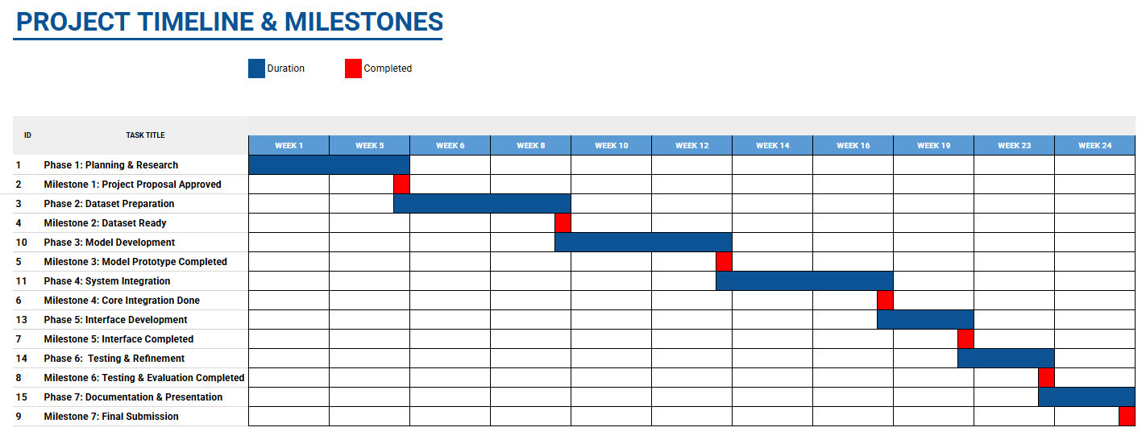
Figure 1: Gantt chart project timeline

Timeline Summary

Table 11: Development timeline
Timeline | Activity
Weeks 1–5 | Planning, Research & Requirements Analysis
Weeks 5–8 | Dataset Preparation & Annotation
Weeks 8–12 | Model Development & Training
Weeks 12–16 | System Integration
Weeks 16–19 | Interface Development
Weeks 19–23 | Testing & Refinement
Weeks 23–24 | Documentation & Final Submission

Team Responsibilities

Table 12: Project team responsibilities
Member | Feature / Task | Role | Deliverable
Aagna  (Team Leader) | Machine Learning Model Development | Develops and trains the core AI model for facial expression and gesture detection using TensorFlow/PyTorch. Manages dataset training, testing, and fine-tuning. | Trained and validated ML model with performance metrics.
Samia  (Scribe) | Frontend Interface Development | Integrates all modules (ML, frontend, backend) into a single coherent system. Supports real-time camera input, model inference, and TTS output. | Fully integrated working prototype with real-time capability.
Sofia | System Integration & Real-Time Processing | Designs and develops an accessible user interface using pywebview. Ensures the layout is user-friendly and tailored for visually impaired users. | Fully functional UI prototype with accessibility features.
Anelle | Dataset Collection & Preprocessing | Collects and preprocesses image and video datasets for training. Applies labelling, normalisation, and augmentation to improve model performance. | Cleaned and structured dataset with preprocessing scripts.
Sara | Backend & API Development | Builds backend logic using Flask/FastAPI. Manages data flow between the model, UI, and TTS engine; develops RESTful API endpoints. | Working backend with defined APIs and functional test results.
Sandra | UX & Prototype Enhancement | Performs unit and integration testing to verify system stability and data security. Evaluates model accuracy under varying real-world conditions. | Final test report with bug reports and security validation summary.
Sanura | Testing, Debugging & Security Review | Enhances frontend usability, adds accessibility features, and refines visual flow. Supports frontend styling and demo preparation. | Improved prototype UI with enhanced UX and presentation-ready demo.

System Requirements

Business Context
In the post-pandemic era, the use of online video meetings as a platform for official and educational discussion has become an increasingly widespread channel for continuing operations when face-to-face meetings are not possible. While video meetings provide an efficient solution for remote connections, as a primarily visual medium, it does not adequately address accessibility issues for those with visual impairments. Video calls as a medium employ visual cues such as the user’s expressions and gestures which, when imposed upon the audio, are a core component of what’s being communicated. SOVA bridges this gap in communication by providing audio output of visual cues being expressed using computer vision and text-to-speech, without interfering with the existing spoken output during the call.
SOVA was designed to function as a desktop application and Chrome browser extension, distributed as direct-to-consumer. The incoming video frames will be extracted from the screen during the video call and generate output based on the CV framework. The system utilises a local Python-based backend using MediaPipe, PyTorch, and YOLOv8 for machine learning and computer vision tasks; it is built for laptops and PCs. This locality is a deliberate differentiator from other cloud-based competitors, especially in environments where tools routinely face compliance and procurement resistance.

System Features & Data Flow

Figure 2: Data flow diagram
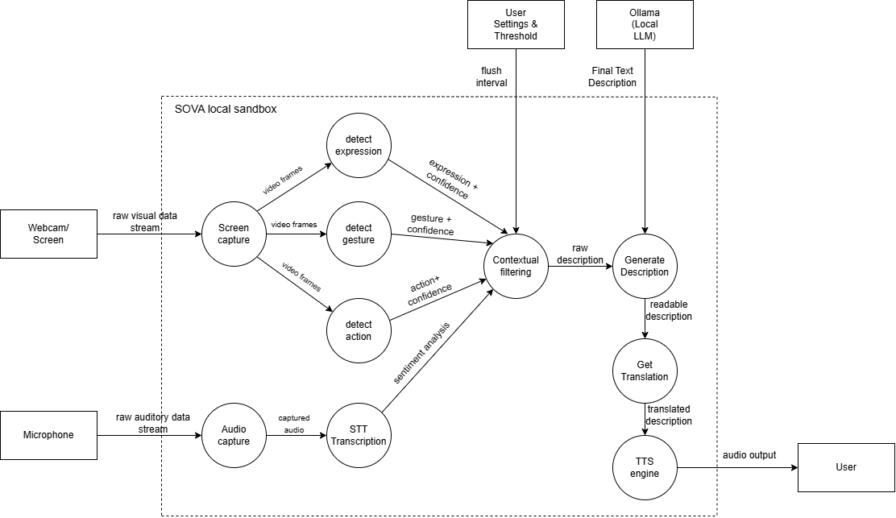

Computer Vision Non-Verbal Cues Detection
SOVA uses computer vision to detect facial expressions, gestures, and body movements in real time from video input. It extracts meaningful non-verbal cues and assigns confidence scores to ensure reliable interpretation. Detected gestures must persist across multiple frames and meet a confidence threshold before being included in the final output, reducing false positives.

Figure 3: CV detection engine flow
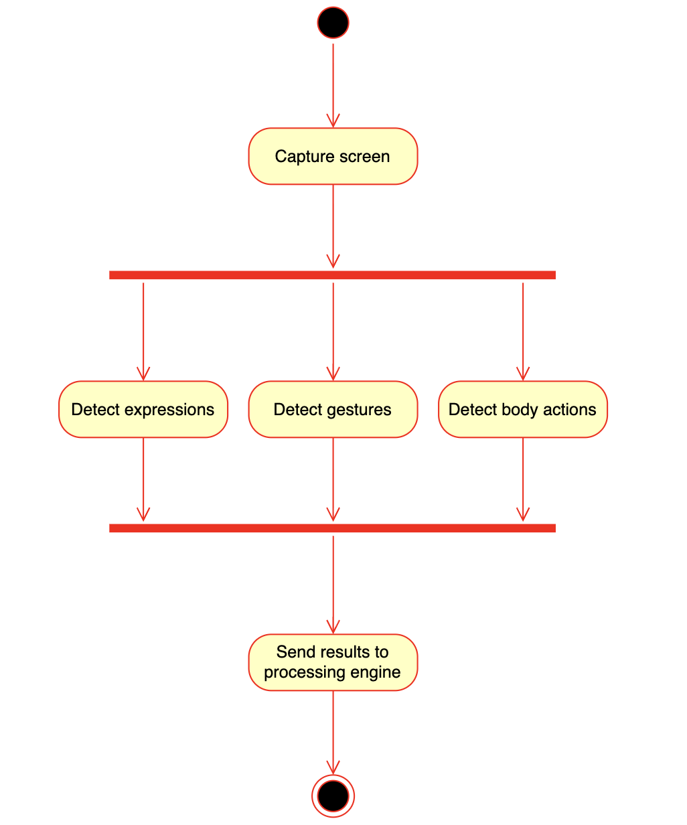

Audio Capture & Transcription
The system captures live audio from the meeting and converts it into a textual transcript using speech-to-text (STT) models. This enables further analysis by providing spoken context alongside visual cues. By combining both modalities, SOVA produces more accurate and context-aware descriptions.

Figure 4: Audio & transcription engine flow
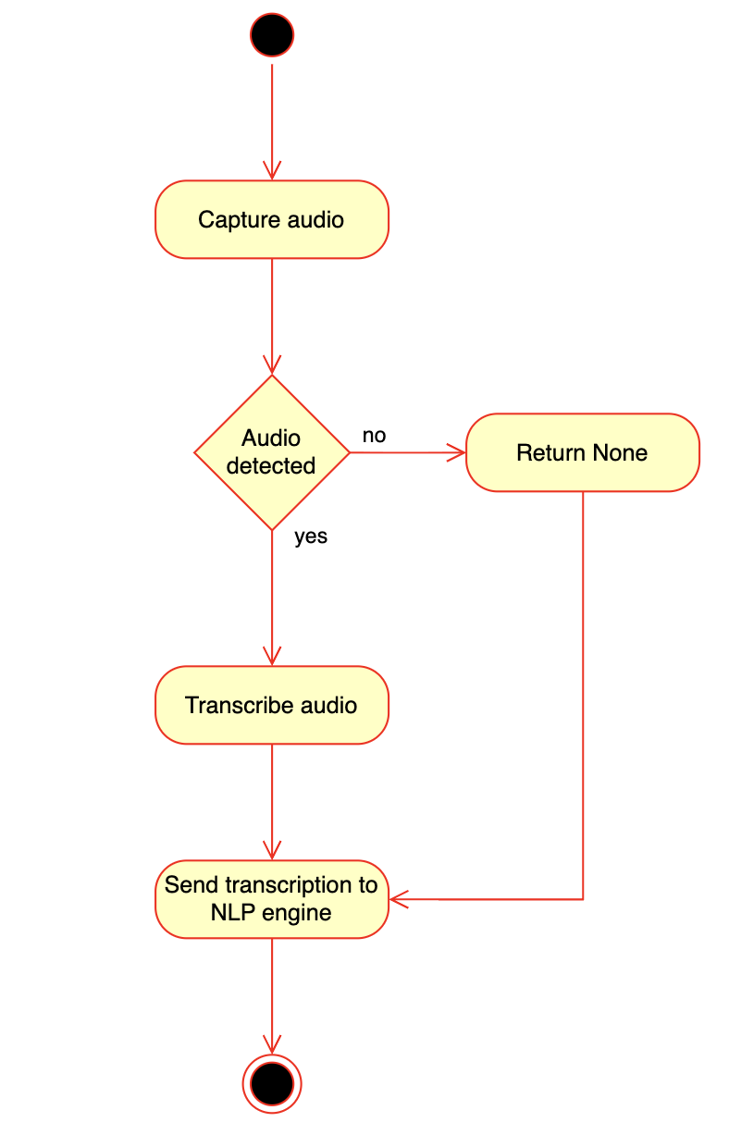

Sentiment Analysis & Processing
Transcribed speech and detected expressions are analyzed to determine the overall emotional tone of the conversation. A processing layer filters noise, prioritizes significant events, and combines inputs into stable outputs. This ensures that only meaningful and consistent information is passed to the next stage.

Figure 5: Processing & sentiment analysis flow
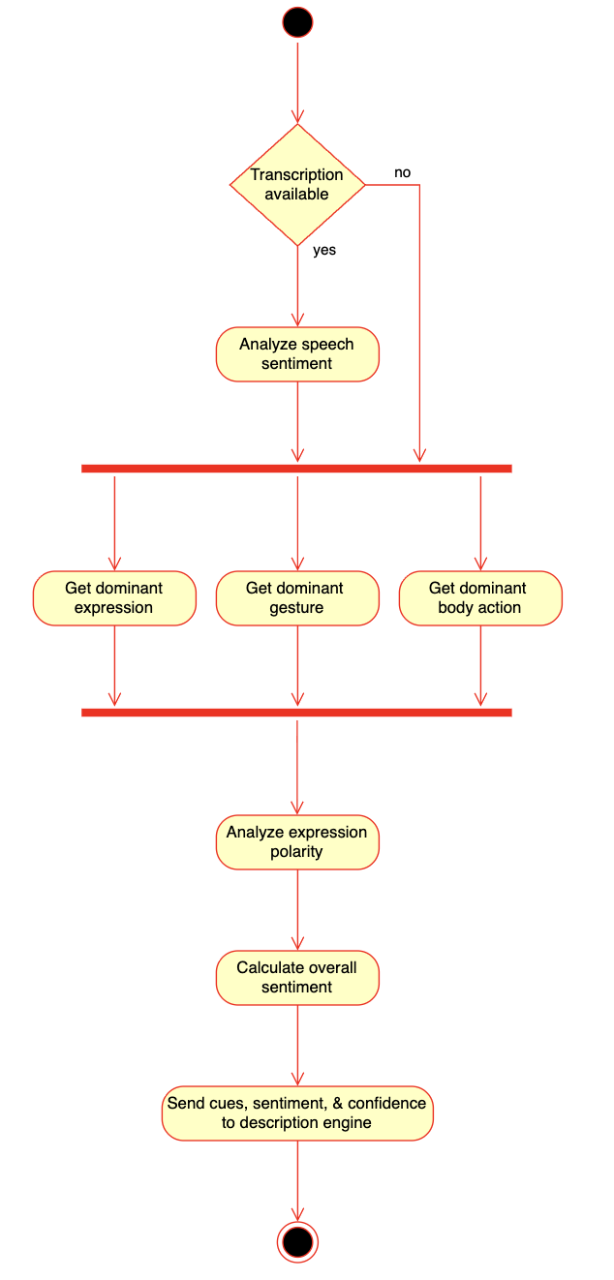

Multilingual Translation Support
SOVA supports multiple languages by translating generated descriptions into the user’s preferred language. The translation process is applied dynamically without interrupting real-time performance. This allows users from different linguistic backgrounds to receive accessible feedback seamlessly.

Figure 6: Translation engine flow
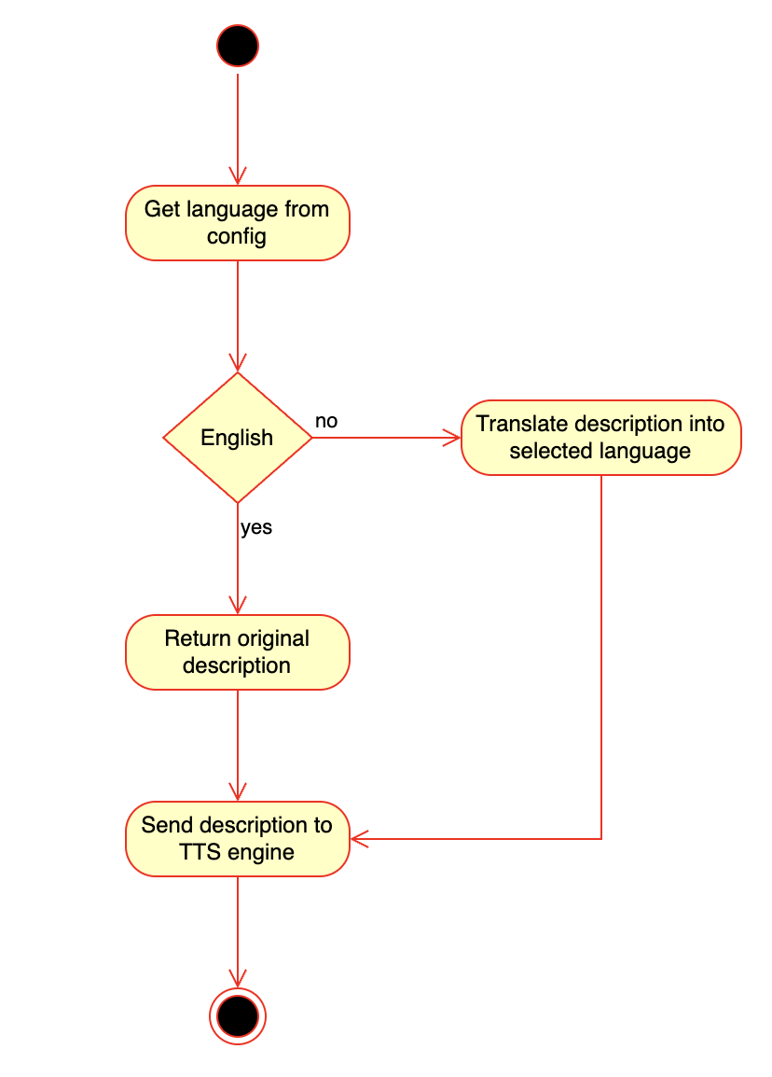

LLM Description Generation
A local language model generates short, natural descriptions based on detected cues and overall sentiment. The output is designed to be concise, clear, and easy to understand in real time. Fallback templates are used when the model is unavailable, ensuring continuous system operation.

Figure 7: Description generation engine flow
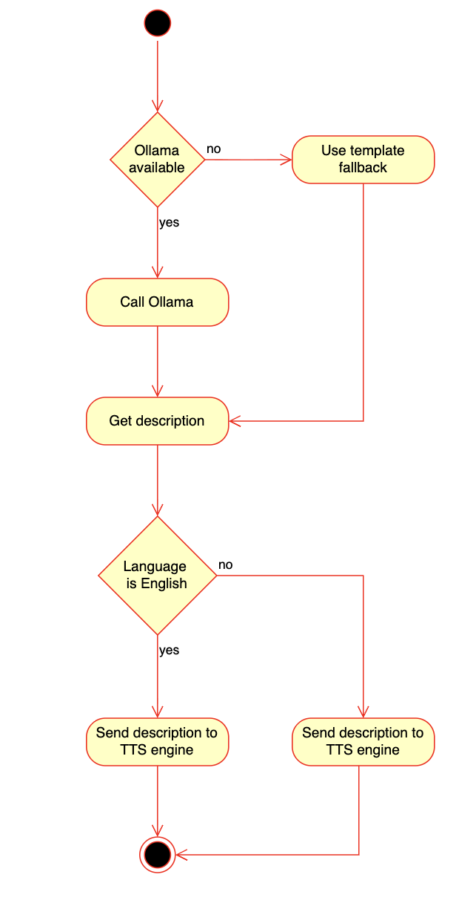

Text-to-Speech Feedback
Generated descriptions are converted into spoken audio using a text-to-speech (TTS) engine. This enables visually impaired users to receive real-time feedback without relying on visual interfaces. The system also supports adjustable volume and voice settings for user comfort.

Figure 8: TTS engine flow
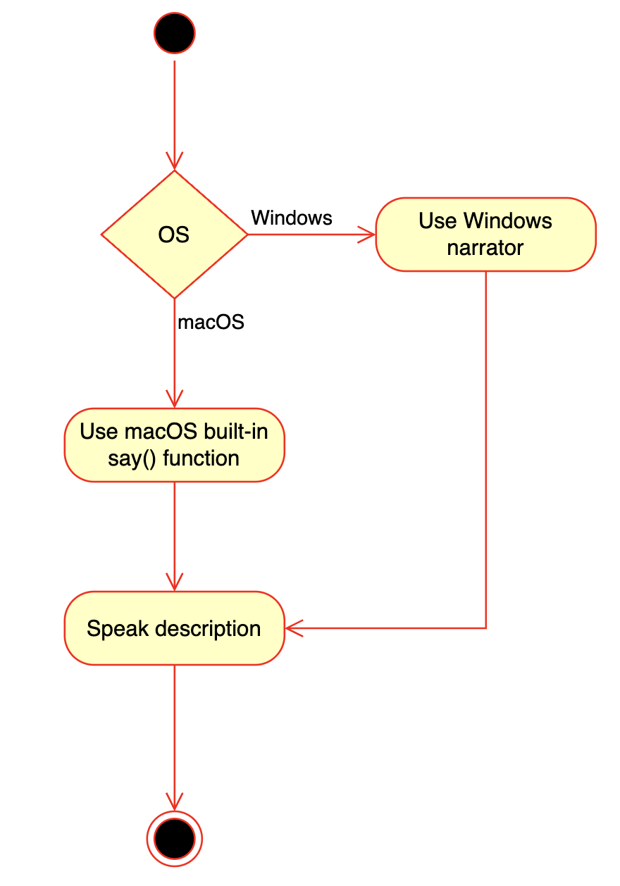

Desktop App Dashboard
The desktop dashboard provides a centralized interface to monitor live results, system status, and user settings. It is designed with accessibility in mind, supporting keyboard navigation and screen readers. Users can control system behavior, such as feedback intervals and language preferences, through this interface.

Figure 9: Dashboard use case diagram
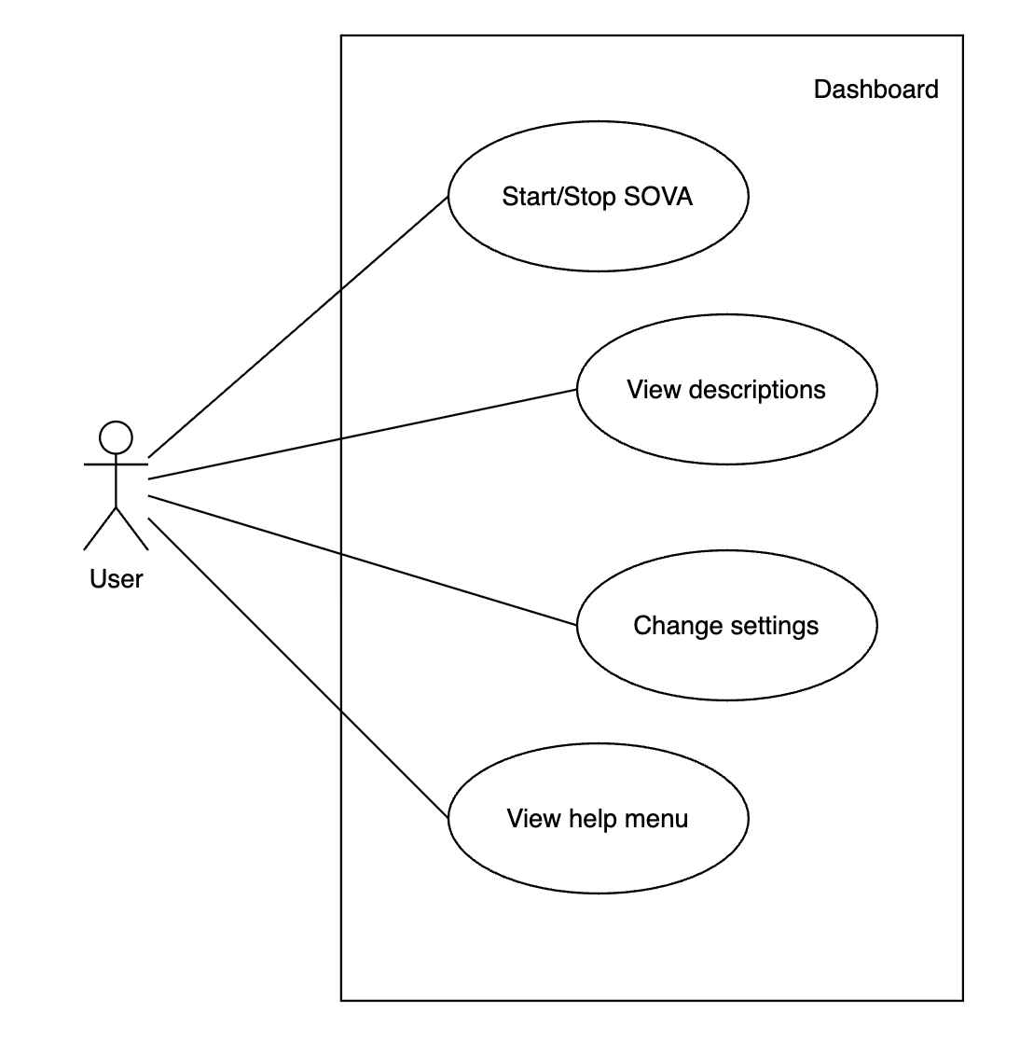

Google Meet Chrome Extension
The Chrome extension integrates SOVA directly into Google Meet by displaying real-time overlays during calls. It allows users to quickly access controls and view outputs without switching applications. The extension stays synchronized with the main system through a WebSocket connection, ensuring consistent real-time updates.

Figure 10: WebSockets extension flow
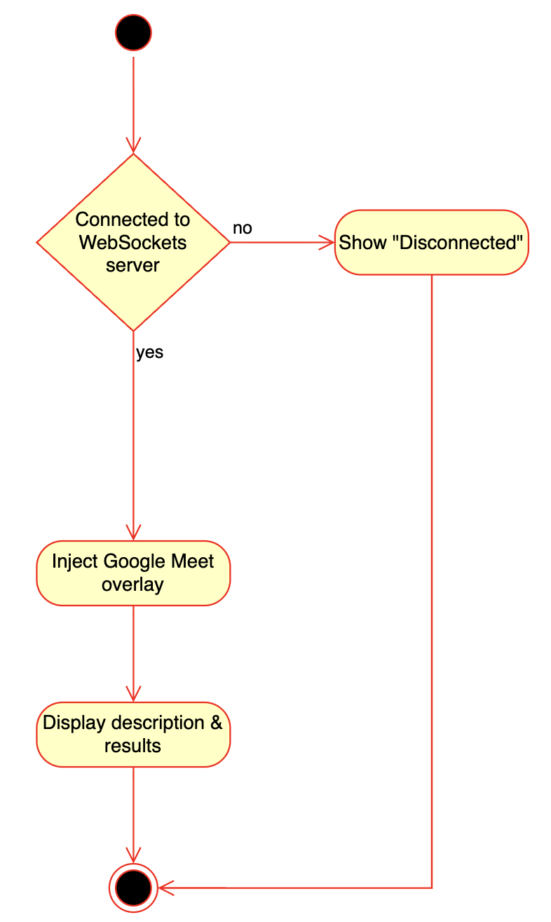

Functional Requirements
ID | Requirement Description | Input Data | Output Data | Responsible Module
FR-1 | Capture frames from a webcam or screen (one active source). | Device camera / screen | Raw video frames | Screen Capture
FR-2 | Continuous mic capture with chunk queuing and vision-only fallback. | Device microphone | Audio chunk queue | Audio Capture
FR-3 | Use MediaPipe Face Mesh for landmark-based classification. | Video frame | Expression label + confidence | Expression Model
FR-4 | Detect gestures via MediaPipe/YOLO. | Video frame | Gesture label + confidence | Gesture Model
FR-5 | Detect presence of person in frame and looking away | Video frame | Action label + confidence | Body Action Model
FR-6 | Transcribe queued audio chunks into text transcripts. | Audio chunk queue | Text transcripts | STT Engine
FR-7 | Buffer frame results and flushes stable metadata based on thresholds. | Per-frame results | Stable filtered metadata | Processor Module
FR-8 | Derive sentiment from accumulated audio transcripts and visual cues. | Accumulated transcripts | Sentiment + confidence | Processor Module
FR-9 | Generate human-readable descriptions using Ollama or template fallback. | Filtered metadata | Natural language description | Ollama (Local LLM)
FR-10 | Translate descriptions into English, Arabic, French, or Spanish. | English description | Translated description | Translator Module
FR-11 | Synthesize audio using language-specific system voices. | Translated description | Audio speech output | TTS Engine
FR-12 | Broadcast Real-time payload to Dashboard and Chrome Extension. | Flush result payload | WebSocket message | WebSocket Server
FR-13 | Hot-reloading of volume, language, and thresholds via user settings. | User settings input | Updated config + reload | Config Module

Non-Functional Requirements

Table 13: Non-functional requirements
ID | Requirement | Description
NFR-1 | Usability | The system should provide an intuitive and accessible interface designed for visually impaired users, supporting voice interaction and minimal visual dependency.
NFR-2 | Accessibility | The system must comply with WCAG 2.1 guidelines to ensure inclusive usage for users with disabilities.
NFR-3 | Reliability | The system should operate continuously during long sessions (up to 2 hours) without crashes or interruptions.
NFR-4 | Availability | The system should maintain at least 99% uptime during active usage.
NFR-5 | Scalability | The architecture should support future extensions such as multi-platform integration and additional AI modules.
NFR-6 | Maintainability | The system should be modular and use well-documented open-source technologies to allow easy updates and debugging.
NFR-7 | Compatibility | The system should function across multiple operating systems (Windows, macOS, Linux).
NFR-8 | Efficiency | The system should optimize CPU and memory usage to run smoothly on standard hardware.

Data Requirements

Table 14: Data requirements
Data Type | Requirement Description
Input Data | - Real-time video frames from screen capture or webcam  - Audio streams from meetings  - User preferences (language, tone, verbosity)
Processed Data | - Facial expressions, gestures, and body actions with timestamps  - Speech transcripts and sentiment scores  - Intermediate feature vectors for AI models
Output Data | - Structured metadata (JSON format)  - Natural language descriptions  - Audio output via TTS
Storage Constraints | - No permanent storage of raw video/audio  - Temporary buffers cleared after processing  - Optional logs for performance tracking
Data Sources | - Open-source datasets (FER-2013, AffectNet, MPII, HaGRID)

Interface Requirements

Table 15: Interface requirements
ID | Requirement | Description | Interfaces / APIs
IR-1 | User Interface | The system should provide an accessible dashboard with screen-reader support and simple navigation. | pywebview, HTML/CSS/JS
IR-2 | Input Interface | The system should accept video input via webcam or screen capture. | OpenCV, MediaPipe
IR-3 | Module Communication | The system should exchange data between modules using JSON format. | REST API, WebSockets
IR-4 | External Integration | The system should integrate with Google Meet via a Chrome extension overlay.The system should integrate with Google Meet via a Chrome extension overlay. | Chrome Extension APIs
IR-5 | Audio Output | The system should deliver audio output through speakers or headphones. | OS Audio APIs (PyAudio/PortAudio)
IR-6 | NLP & TTS Interface | The system should connect NLP and TTS modules for generating and delivering speech output. | FastAPI, pyttsx3

Performance Requirements

Table 16: Performance requirements
ID | Requirement | Description
PR-1 | Latency | Detection latency should not exceed 2 seconds from frame capture to result.
PR-2 | Response Time | End-to-end delay (detection to speech output) should not exceed 1 second.
PR-3 | Throughput | The system should process at least 10 frames per second on CPU.
PR-4 | Accuracy | The system should achieve at least 90% accuracy in detecting expressions and gestures.
PR-5 | NLP Accuracy | Generated text should maintain at least 95% grammatical accuracy.
PR-6 | Resource Usage | CPU usage should remain below 20% on standard devices.
PR-7 | Memory Usage | The system should use less than 500 MB of memory during operation.
PR-8 | Concurrency | The system should handle simultaneous execution of CV, NLP, and TTS modules efficiently.

Security Requirements

Table 17: Security requirements
ID | Requirement | Description
SR-1 | Local Processing | All video and audio data should be processed locally by default.
SR-2 | Privacy Protection | The system should not store raw video/audio or personally identifiable information.
SR-3 | Data Anonymization | Only anonymized metadata should be stored temporarily.
SR-4 | Authentication | Users should be authenticated before accessing dashboard features.
SR-5 | Compliance | The system should comply with GDPR, UAE PDPL, and ISO/IEC 27001 standards.
SR-6 | Secure Communication | All external communications should use HTTPS protocols.

Operational Requirements

Table 18: Operational requirements
ID | Requirement | Description
OR-1 | Operating System Support | The system should run on Windows, macOS, and Linux.
OR-2 | Integration | The system should operate alongside video conferencing tools like Google Meet and Zoom.
OR-3 | Hardware Dependency | The system should require a webcam, microphone, and audio output device.
OR-4 | Auto-Recovery | The system should automatically recover from camera or audio input failure.
OR-5 | Adaptability | The system should adjust to different resolutions and lighting conditions.
OR-6 | Installation | The system should have a simple setup process for end users.

Legal & Political Requirements

Table 19: Legal & Political requirements
ID | Requirement | Description
LR-1 | Data Privacy | The system must comply with UAE PDPL and GDPR regulations.
LR-2 | Accessibility Compliance | The system must follow WCAG 2.1 accessibility standards.
LR-3 | User Consent | The system must obtain explicit user consent before accessing audio/video data.
LR-4 | API Usage | External APIs should only be used with user approval.
LR-5 | Licensing | All software components must comply with open-source licenses (MIT, Apache, BSD).
LR-6 | Ethical Use | The system must not perform facial recognition or identity tracking.

Software & Hardware Requirements

Table 20: Software requirements
ID | Requirement | Description
SWR-1 | Programming Language | Python 3.10+ / 3.11+ should be used for system development.
SWR-2 | CV Libraries | MediaPipe and OpenCV should be used for vision processing.
SWR-3 | NLP Libraries | PyTorch, Transformers, and Whisper should be used for NLP tasks.
SWR-4 | TTS Engine | pyttsx3 should be used for offline speech generation.
SWR-5 | Backend | FastAPI or Flask should handle communication between modules.
SWR-6 | GUI | pywebview and web technologies should be used for dashboard interface.

Table 21: Hardware requirements
ID | Requirement | Description
HWR-1 | Minimum CPU | Intel i5 / Ryzen 5 processor required.
HWR-2 | Memory | Minimum 8 GB RAM required.
HWR-3 | GPU (Optional) | GPU with 4GB VRAM recommended for better performance.
HWR-4 | Devices | Webcam, microphone, and speakers/headphones required.

Constraints & Open Issues
Constraints include the following:
- Hardware Limitations
  - Performance depends on user device (CPU, RAM, GPU).
  - Low-end devices may experience higher latency and slower processing.
- Environmental Conditions
  - Accuracy may drop due to poor lighting, occlusions, or low-quality cameras.
  - Background noise can affect speech recognition accuracy.
- Model Limitations
  - Pre-trained models may not generalize well across all users or cultural gestures.
  - Gesture detection depends on clear visibility of hands and face.
- Platform Dependency
  - Integration relies on third-party platforms like Google Meet.
  - API restrictions and updates may impact functionality.
- Real-Time Processing Constraints
  - Balancing speed and accuracy is required for real-time performance.
  - High system load may require frame skipping.
- Budget Constraints
  - Limited to open-source tools and free-tier services.
  - No dedicated funding for premium APIs or infrastructure.
- Time Constraints
  - Development restricted to academic timeline.
  - Limited time for extensive testing and advanced features.
Open issues include the following:
- Multi-Person Recognition
  - Not fully implemented; future work needed for tracking multiple participants.
- Cloud Integration
  - Decision pending between local-only or hybrid/cloud processing.
- API Limitations
  - Dependence on conferencing platforms may limit scalability and stability.
- Model Bias
  - Requires more diverse datasets to improve fairness and accuracy.
- Accuracy Improvements
  - Further enhancement needed for gesture and emotion detection.
- Platform Expansion
  - Future integration planned for Zoom, Microsoft Teams, etc.

Preliminary Budget

Table 22: Budget breakdown
Category | Description | Estimated Cost
Software & Tools (Open-source) | Mostly open-source, but includes potential paid tools/plugins or upgrades | 0 – 185 AED
Development Tools | IDEs are free, but version control, storage, or add-ons may incur minor costs | 0 – 110 AED
Optional APIs | Free tiers available, but real usage may exceed limits | 75 – 370 AED/month
Hardware | Assumes existing laptops, but realistic depreciation/upgrade cost considered | 0 – 1,100 AED (one-time)
Testing & Data | Dataset acquisition, preprocessing, and testing tools | 75 – 295 AED
Miscellaneous | Internet usage, backups, unexpected expenses | 75 – 185 AED

System Design

System Overview
SOVA operates as a dual-component architecture, including a Python-based local desktop application where the AI processing and analysis takes place, and a Chrome browser extension that integrates with Google Meet. All data is processed entirely locally on the user's device, ensuring complete privacy and low latency.
The core functionality of the system depends on continuous multimodal analysis. Expressions, gestures, and body actions detected using MediaPipe. YOLOv8 object detection is used to track phone usage. Faster-whisper is utilized to transcribe meeting audio on which sentiment analysis is performed using DistilBERT NLP models. All of these detection streams are aggregated over certain time intervals (set to 30 seconds by default) to produce a comprehensive, stable and high-confident output, ensuring reduced cognitive overload. Natural language descriptions are generated using either Ollama or a template-based fallback when Ollama is unavailable. These sentences can then be translated into the user’s preferred language and delivered via text-to-speech. This TTS runs parallel to the video call as audio narration, ensuring there is no overlap with the meeting participants.
Accessibility is at the forefront of the system design goals and has driven multiple design decisions, such as keyboard-only navigation, user-adjustable settings to balance the detection thresholds and avoid false-positives, and using confidence based scoring in the case of uncertain detections to ensure full transparency and accuracy. SOVA’s event scheduling layer helps filter out any repetitive descriptions, ensuring that only the most meaningful behavioral changes are converted into audio feedback.

System Architecture

High-Level Architecture

Figure 11: Container diagram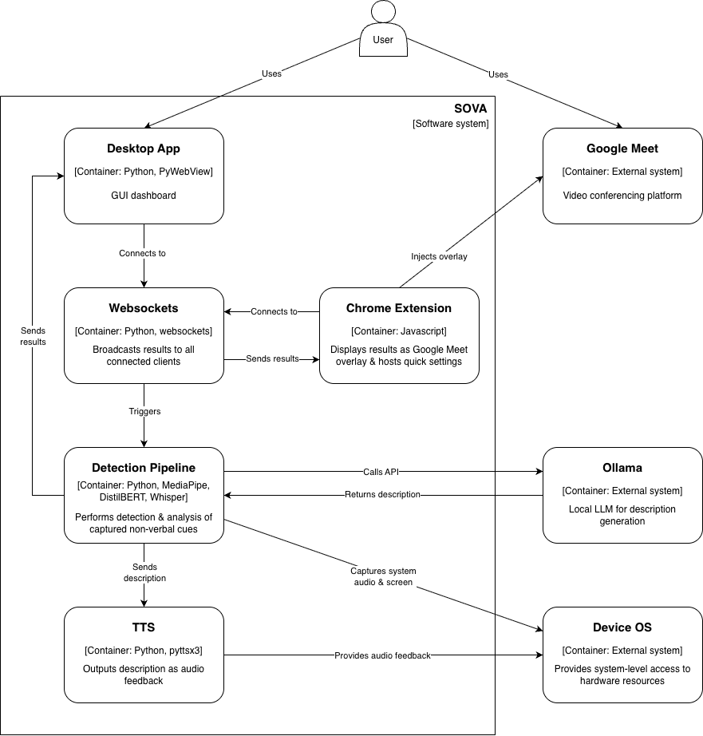

Figure 12: Sequence diagram
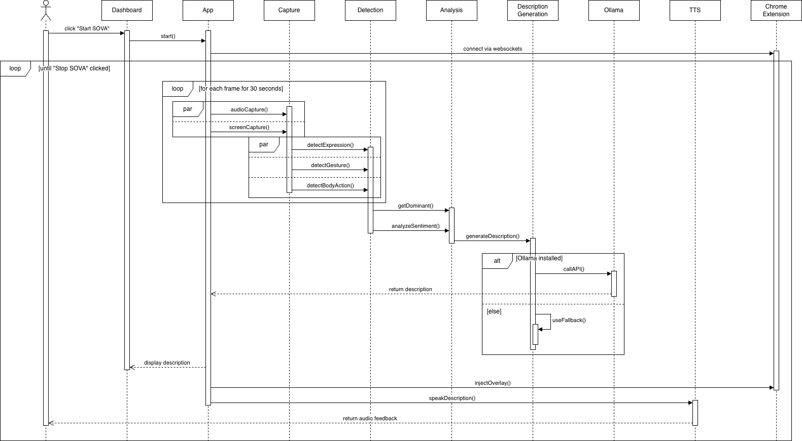

SOVA’s architecture consists of the following:
- A Desktop application responsible for hosting the WebSocket server as well as the main processing hub where the AI detection pipeline for vision, audio, NLP and descriptions are processed.
- PyWebView which is used to generate the dashboard.
- The Chrome Browser Extension connects to the WebSocket server which is responsible for receiving real-time results and displaying them on the popup dashboard as well as an overlay inside Google Meet.
- Any settings changed in the extension are fed back to the backend utilizing a WebSocket channel, ensuring synchronization between the extension and the application.

The sequence diagram outlines the end-to-end flow of a single detection cycle from when SOVA is started till when SOVA is stopped. Once the user clicks on “Start SOVA” the desktop application will initialize the detection engine on the background thread. Video frames and audio are captured continuously and the 3 CV pipelines for expression, gesture and body action, along with the STT pipeline generate outputs which are buffered. At every flush interval, the buffered detections are aggregated by the processor, after which sentiment fusion occurs. Next, a description is requested from Ollama (if unavailable, falls back on templates), optionally the description is translated and the result payload is broadcasted to the WebSocket channel. Both the dashboard and the Google Meet overlay receive this broadcast simultaneously and their displays are updated( maintaining synchronicity). TTS audio is parallely delivered to the user.

Component Decomposition
SOVA is logically separated into 4 layers (Figure 5) which are each responsible for a particular stage of the pipeline.
The Data Acquisition Layer consists of screen_capture.py and audio_capture.py. The MSS library is utilized to collect frames at native resolution, while platform-specific backends are used for the audio capture, such as: ScreenCaptureKit for macOS 13+, WASAPI for Windows and PulseAudio for Linux. These platform-specific backends enable audio capture without using additional drivers on most platforms.
The three parallel CV modules and the NLP engine are components of the AI Processing Layer. MediaPipe Face Landmarker is used in expression.py to extract 478 facial landmarks per frame, after which it is classified into seven expressions after analysing using a geometric threshold. MediaPipe Hand Landmarker and YOLO are used in gesture_v4.py to classify 13 hand gestures and also detect phone usage. MediaPipe Pose Landmarker is used in body_action.py to determine whether the participant is present and their current attention state. Faster-whisper is run on stt_engine.py enabling local transcription of speech, after which text is fed into nlp_engine.py, which classifies sentiment using DistilBERT.
The Event Processing Layer is implemented in processor.py. Raw frame-level detections are buffered over a flush interval ( set to 30 seconds by default) which can be configured. Weighted dominant signal selection is then applied, resulting in stable output per category. NLP output (60%) and expression polarity (40%) are combined during sentiment fusion to generate a comprehensive emotional state estimate.
The Output & Delivery Layer consists of description_engine.py, translator.py, tts_engine.py, and the WebSocket broadcast system. The locally hosted Ollama LLM (llama3.2:3b) generates descriptions which can optionally be translated using deep-translator and then spoken aloud via pyttsx3 or native macOS TTS. Next, it is broadcasted as a JSON payload to all connected WebSocket clients. These payloads are routed to the dashboard and the Google Meet content script using the chrome extension’s background.js .

Design Rationale
Deliberate architectural choices heavily shaped how SOVA was built.
Local-processing was implemented in order to guarantee data privacy. AI inference during video analysis, audio transcription and language model generation, all run on the user’s device. No audio or video / personal data is transmitted to any external servers, ensuring that confidential professional calls or medical calls are completely private and secure.
In order to eliminate instability and recurring outputs for every frame, temporal aggregation over a 30-second window was implemented. Micro-movements and lighting changes could trigger fluctuating detections, which can be repetitive, unintelligible and cause an overlap with TTS announcements as well. This 30-second window was deliberately selected after testing, to ensure an optimal balance between stability and responsiveness, with category specific neutral thresholds (60% for expressions, 95% for gestures, 70% for body actions), which considers the variation in the baseline distributions for each category.
Multi-modal fusion allows independent degradation of the audio and visual pipelines. In case of failure of the audio capture system due to driver issues or system permissions, SOVA will continue to provide gesture, expression and body-action descriptions without sentiment generation. This prevents failure of the entire system in case a single component malfunctions.
A fallback template is implemented with the Ollama LLM ensuring reliability. Natural and contextually-aware sentences are produced by the LLM for novel detection combinations, but when Ollama is unavailable or not installed, the template system guarantees continued consistent output.
The architecture of the Chrome extension ensures seamless integration with Google Meet’s DOM via content script injection. The WebSocket communication between the AI backend and the UI frontend is decoupled, ensuring easy future compatibility and expansion (with other video conferencing platforms like Zoom or Teams).

High-Level Process Flow
When SOVA is launched, app.py will load configuration from config.json and then initialize all AI models (MediaPipe, Whisper, DistilBERT, YOLOv8n) after verifying if Ollama is available or not. Next, the WebSocket server is launched on a background thread and the PyWebView dashboard is rendered.
When “Start SOVA” is clicked, the main detection engine is initialized on a separate thread.
During each detection cycle the following loop takes place: a frame is captured and passed to the 3 parallel CV pipelines: a) (Label,confidence level) is returned by expression.py based on facial landmark geometry. b) The most dominant hand gesture or phone usage is returned by gesture_v4.py. c) The participant’s attention state and presence is returned by body_action.py.
Simultaneously, audio is captured by audio_capture.py and chunks are fed to the stt_engine.py for transcription.
The buffers are aggregated by processor.py, selecting the weighted dominant signal at the end of every flush interval. Sentiment fusion across the NLP and expression polarity scores takes place after which the stable result is passed on to description_engine.py. If Ollama is not available, a template fallback will produce the description, otherwise a structured prompt will be sent to the Ollama API. Optional translation then takes place and broadcasted as a JSON payload via WebSocket.
The Chrome extension popup, Google Meet overlay and the PyWebView dashboard are updated simultaneously. Finally, TTS audio output is delivered to the user on a background thread followed by clearing of the detection buffer in preparation for the next interval.
Upon clicking “Stop SOVA”, system shutdown is triggered. The engine thread is signalled to exit cleanly after the completion of the current interval. The audio and transcription threads are also exited and a final engine_status message is sent to all connected WebSocket clients.

Data Design

Data Description
Five categories of data are handled by SOVA, all of which are local and transient. After a session ends, no personally identifiable or biometric data, or any contents of the meeting are persisted to the disk beyond what the user has configured.
Real-Time input streams: 15-30 frames are recorded per second as NumPy BGR arrays (form H×W×3, uint8) and are immediately deleted after CV processing. Audio is recorded as float32 mono arrays at 16kHz and stored in a thread safe queue after being transcribed, followed by immediate disposal.
Intermediate Processing Data: Geometric features are extracted from MediaPipe which detects 478 facial landmarks, 21 hand landmarks per hand and 33 pose keypoints. Bounding boxes along with confidence scores for phone usage detection are produced using YOLOv8n. Once dominant features are extracted, all raw landmark object data is discarded.
Aggregated Event Data: Over the flush interval, (Label, confidence) tuples are accumulated by the processor in the three category buffers. Each category typically has a buffer size of 450–900 tuples (15–30 FPS × 30 seconds). A stable result tuple is generated using dominant signals, sentiment fusion and the final description string, after flushing. All buffers are cleared after every flush.
Configuration & State Data: Only operational settings such as flush interval, TTS parameters, language and the Ollama model, are stored persistently in config.json. The runtime state which includes the flush timer, baseline facial measurements and all active WebSocket connections is held in memory only.
Output Data: Metadata and detection results are carried by a JSON object in the WebSocket broadcast payload. TTS audio is delivered via the system’s audio output, after being synthesised in real-time. It is never recorded to memory. The most recent/latest outcome is rendered as stylised HTML components directly inside the Google Meet interface by the Chrome extension overlay.

Data Dictionary
​​The following table lists the major data entities used across the SOVA system, along with their associated type and descriptions, based on the system’s design and functional requirements.

Table 23: Data dictionary
Entity Name | Data Type | Description
_action_buffer | List[(str, float)] | Accumulates (action_label, confidence) parameters during flush interval for body action aggregation
_expr_buffer | List[(str, float)] | Accumulates (expression_label, confidence) parameters during flush interval for expression aggregation
_gest_buffer | List[(str, float)] | Accumulates (gesture_label, confidence) parameters during flush interval for gesture aggregation
_next_flush_time | float | Timestamp indicating when next flush should happen
_ollama_ready | bool | Flag indicating whether Ollama is available and ready for description generation
_ws_clients | Set[WebSocket] | Collection of active WebSocket client connections for real-time broadcast
accumulated_transcripts | List[str] | Transcriptions accumulated during current flush interval for sentiment analysis
action | str | Dominant body action detected in aggregation window
audio_chunk | ndarray[float32] | Single buffer of audio samples captured from system audio
baseline_brow | float or None | Reference eyebrow height established during initial frames
baseline_eye | float or None | Reference eye openness established during initial frames
blended_score | float | Weighted combination of NLP sentiment score (60%) and expression polarity score (40%)
confidence | float | AI model confidence score ranging 0.0-1.0 indicating detection certainty
description | str | Natural language sentence describing behavioral state
expression | str | Dominant facial expression in aggregation window
face_landmarks | NormalizedLandmarkList | MediaPipe output containing 478 facial keypoints with normalized coordinates and visibility scores
flush_interval | int | Seconds between aggregation flushes; configurable parameter controlling detection frequency with 30s as default
frame | ndarray[uint8] | Video frame in BGR color space with shape; ephemeral single-iteration data
gesture | str | Dominant hand gesture in aggregation window
hand_landmarks | List[HandLandmarks] | MediaPipe output containing 21 hand keypoints per detected hand with normalized coordinates
language | str | ISO language code for translation target
nlp_conf | float or None | Sentiment classification confidence from DistilBERT model; None if no transcripts available
nlp_label | str or None | Sentiment category from NLP analysis: 'positive', 'negative', or 'neutral'; None if no transcripts
ollama_model | str | Identifier for Ollama model used in description generation with 'llama3.2:3b' as default
overall_conf | float | Fused confidence combining sentiment certainty (60%) and expression confidence (40%)
pose_landmarks | PoseLandmarks | MediaPipe output containing 33 body keypoints for posture and presence detection
sentiment | str | Final emotional state classification; 'positive', 'negative', or 'neutral' from sentiment fusion
sentiment_conf | float | Confidence score for final sentiment classification after sentiment fusion
tts_enabled | bool | Configuration flag controlling whether text-to-speech audio output is active
tts_volume | float | TTS output volume level ranging from 0.0 to 1.0
WebSocket message | JSON object | Structured communication packet with 'type' field and type-specific payload fields
yolo_results | Results | YOLOv8 object detection output containing bounding boxes, class IDs, and confidence scores for detected objects

Component Design

Figure 13: System component diagram
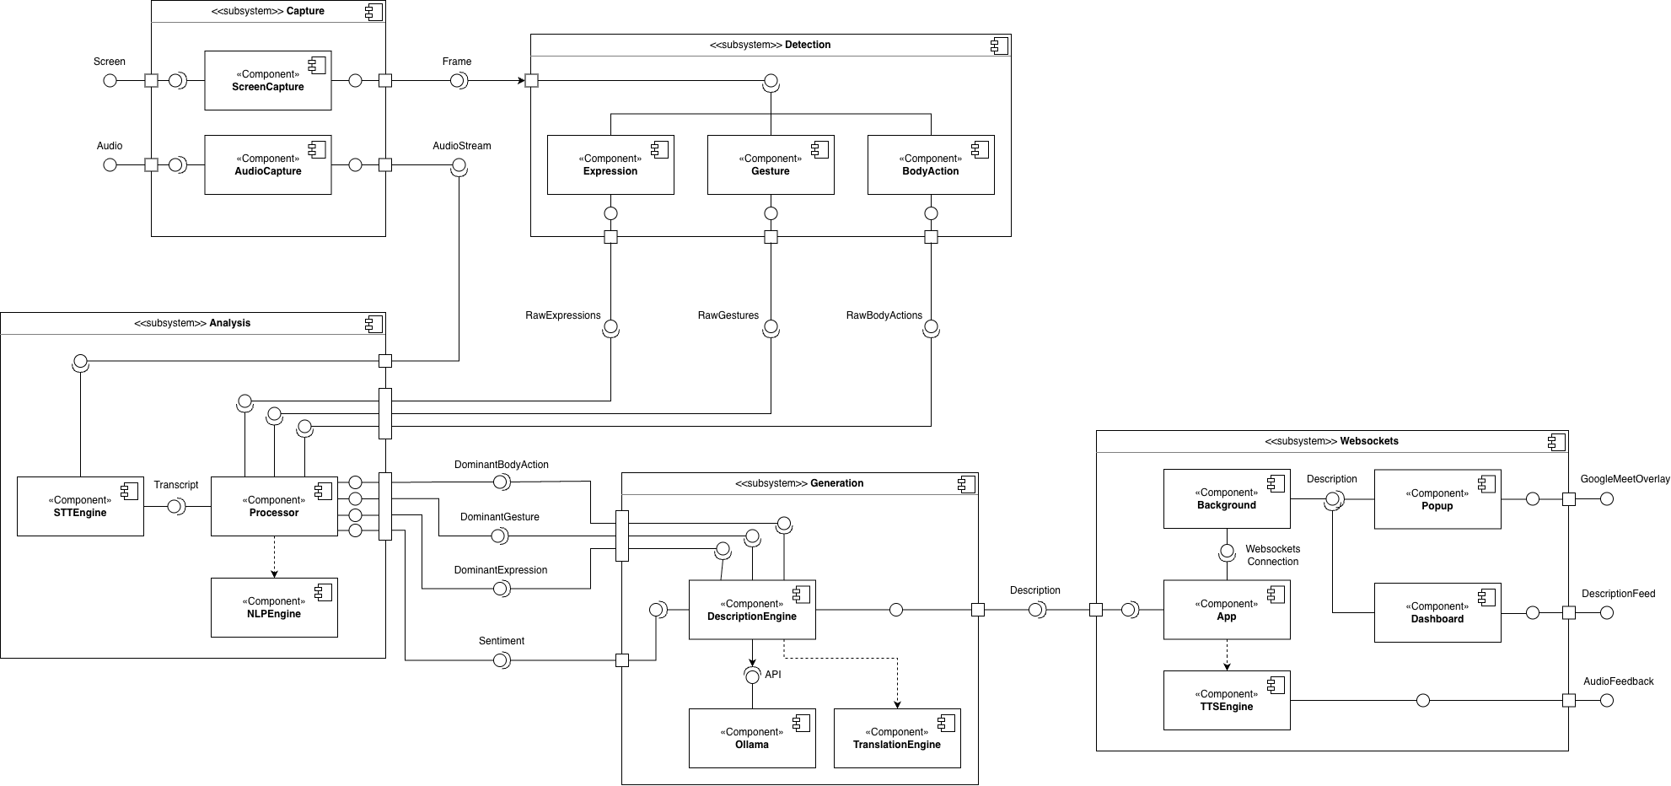
The component diagram above shows the low-level system architecture and how each module was implemented. app.py is an orchestrator that starts the websockets connection with the Chrome extension (if installed) and launches the desktop app dashboard. It calls main.py to start the detection pipeline (starting from Capture) once the user clicks “Start SOVA”.

Expression Detection
INPUT: video frame

Detect face landmarks in frame
IF no face found THEN RETURN “Neutral”

FOR EACH face detected DO
Measure eye openness, brow height, mouth width and depth

IF one eye closed, other open THEN
expression = “Left/Right Wink”
IF mouth sufficiently open THEN
expression = “Mouth Open”
IF mouth wide and no frown THEN
expression = “Smiling”
IF mouth corners pulled down THEN
expression = “Frowning”
IF brows raised above baseline THEN
expression = “Eyebrows Raised”
expression = “Neutral”
END FOR

RETURN expression, confidence

Gesture Detection
INPUT: video frame

IF phone detected in frame THEN RETURN “Using Phone”
IF no hands detected THEN RETURN “No Gesture”

FOR EACH hand detected DO
Determine which fingers are extended

IF Thumb only THEN
gesture = “Thumbs Up/Down”
IF Index only THEN
gesture = “Pointing”
IF Index AND Middle THEN
gesture = “Peace Sign”
IF Thumb AND Index tips touching THEN
gesture = “OK Sign”
IF 4+ fingers AND wrist movement THEN
gesture = “Waving”
IF 4+ fingers AND raised position THEN
gesture = “Hand Raised”
END FOR

RETURN gesture, confidence

Body Action Detection
COMPONENT: BodyActionDetector
INPUT: video frame

Detect body pose landmarks in frame

IF no pose detected THEN
RETURN “No Person In Frame”
END IF

IF ears not visible or too close together THEN
RETURN “Looking Away”
END IF

RETURN “Person Present”

Audio Capture & Transcription
INPUT: system audio stream

Capture audio from system output device
Transcribe audio chunks to text as they arrive
Store transcripts in a queue

EXPOSE drain(): returns all pending transcripts
EXPOSE stop(): releases audio resources

Processor
INPUT: expression, gesture, body action per frame, captions, flush
interval

FOR EACH frame DO
Buffer incoming expression, gesture, body action

FOR EVERY n seconds (flush) DO
SELECT dominant result from each buffer
RUN sentiment analysis on accumulated captions, expression
GENERATE description
CLEAR buffers

RETURN expression, gesture, action, sentiment, description

NLP & Sentiment Analysis Engine
INPUT: list of transcribed caption strings

IF no captions THEN RETURN “Neutral”

Combine captions into one block of text
Run DistilBERT sentiment classifier on text

IF confidence below 0.65 THEN RETURN “Neutral”
ELSE RETURN sentiment, confidence score

TTS Engine
INPUT: description text

IF TTS disabled OR volume is zero THEN RETURN

Speak description aloud at current volume

EXPOSE set_enabled(), set_volume(): runtime control

WebSockets Connection
INPUT: broadcast callable from desktop app

IF broadcast callable provided THEN
Use broadcast callable
ELSE
Start WebSocket server on localhost:8765
END IF

ON message received from client:
Route to appropriate handler:
IF get_config THEN send current settings to client
IF settings THEN apply and broadcast updated config
IF start_engine THEN start SOVA and broadcast status
IF stop_engine THEN stop SOVA and broadcast status

ON broadcast(payload):
Push to PyWebView dashboard via JavaScript bridge
Send to all connected WebSocket clients

Desktop Application
INPUT: N/A

Start WebSocket server on background thread
Load dashboard HTML in PyWebView window
Expose engine controls to dashboard as JavaScript API

start():
IF engine already running THEN RETURN error
Launch SOVA detection loop on background thread
Pass stop event and broadcast function to engine

stop():
Signal engine thread to exit cleanly
Broadcast stopped status to all clients

Chrome Extension
INPUT: N/A

BACKGROUND SERVICE WORKER:
Maintain WebSocket connection to localhost:8765
Reconnect automatically if disconnected

Route incoming messages to correct tabs:
IF results AND config THEN send to dashboard tab
IF results THEN send to Google Meet tab
IF engine status THEN send to all registered tabs

Forward outgoing messages from extension pages to app:
start/stop engine, settings changes, config requests

CONTENT SCRIPT (Google Meet only):
Inject overlay onto the Meet page

ON result received:
Update overlay with latest expression, gesture,
action, sentiment, and description

ON connection lost:
Show disconnected warning in overlay

Interface Design

Overview
The UI consists of an accessibility-first cohesive dashboard designed to align with the Web Content Accessibility Guidelines (WCAG). Navigation is easily performed by using keyboard shortcuts or simply using the mouse. Narration is included when keyboard shortcuts are used for navigation to enhance accessibility for visually impaired users. The “Start/Stop SOVA” button to launch the software is the first thing you encounter, located in the top-right corner next to the connection status. A help menu is provided for users to view or listen to the usage tutorial and keyboard shortcuts.

Table 24: UI sections
UI Section | Description
Status bar | Shows connection status of software.
Latest Description | Displays the latest description after each feedback interval. Only shows the newest description; replaces previous description. Shows confidence level of detected sentiment.
Description Feed | Displays history of descriptions since starting the software. Color-coded green, grey, and red for positive, neutral, and negative sentiment respectively.
Settings | Contains audio feedback toggling, feedback volume, feedback interval, language, and Ollama model settings that users can change and apply.
Help Menu | Contains usage tutorial and keyboard shortcuts.

Figma Mockups

Figure 14: Figma mockup dashboard (connected)
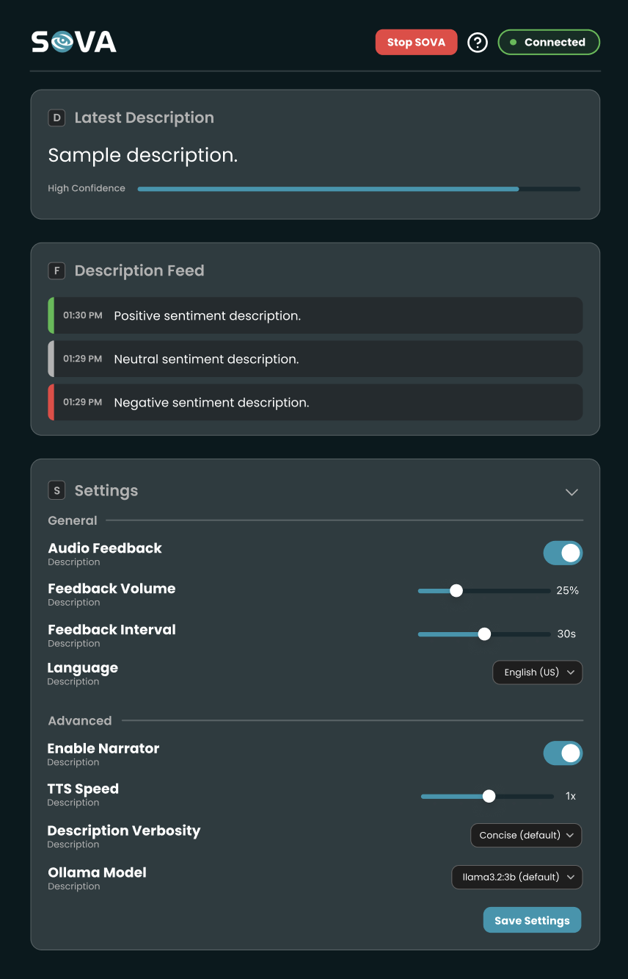

Figure 15: Figma mockup dashboard (disconnected)
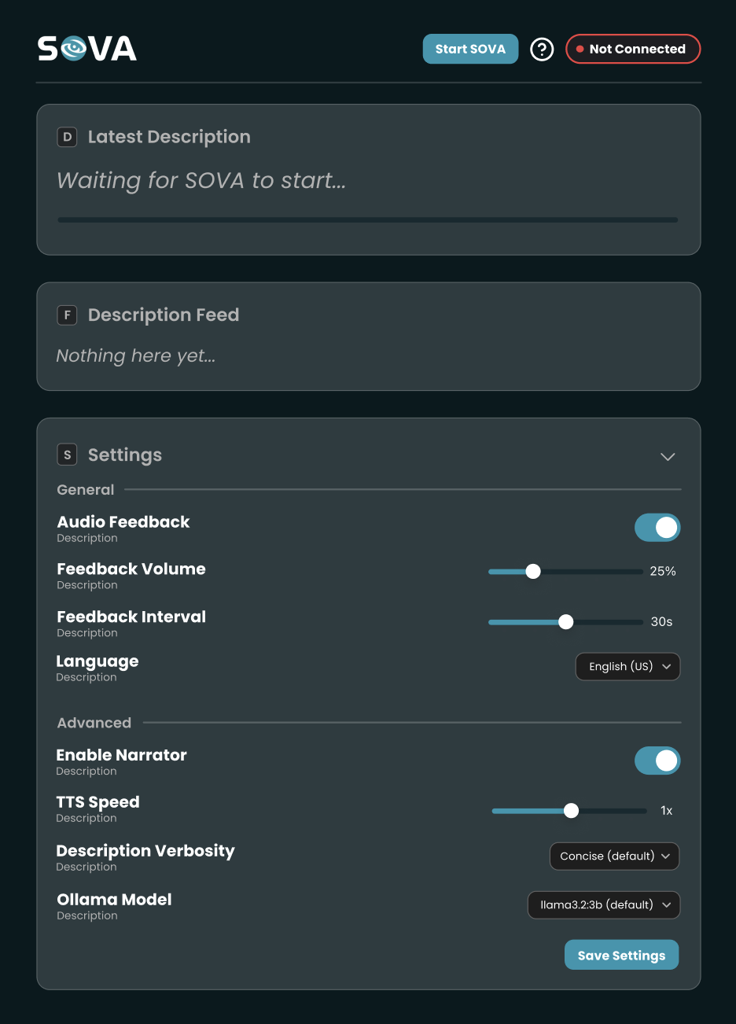

Figure 16: Figma help menu mockup
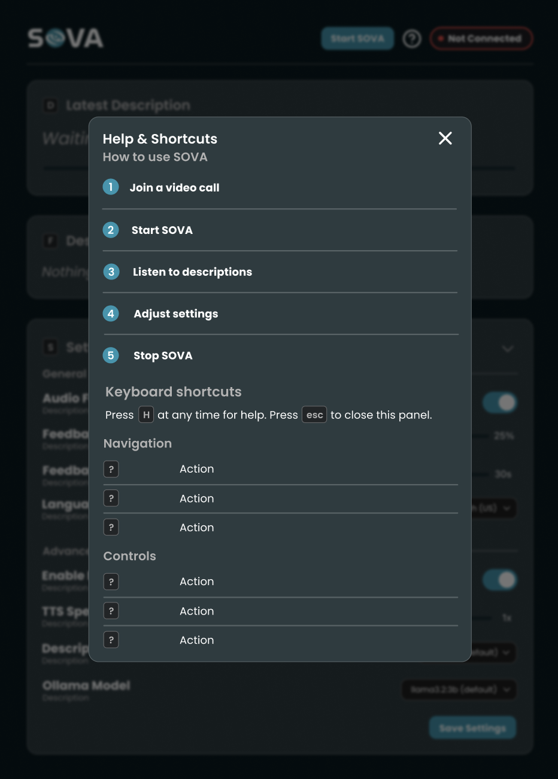
Figure 17: Figma Chrome extension mockup (disconnected)  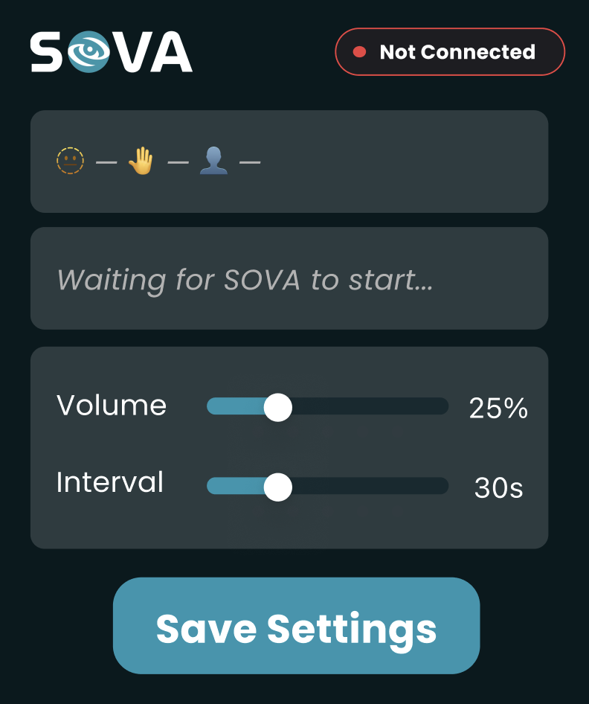 | Figure 18: Figma Chrome extension mockup (connected)  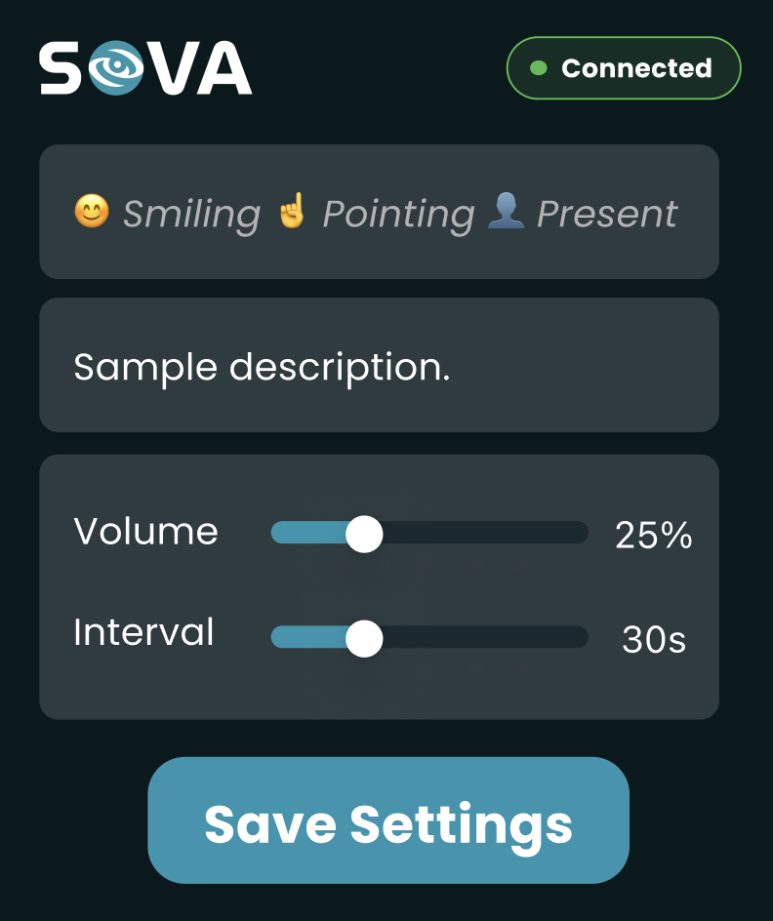

Screen Objects & Actions

Table 25: Screen objects and actions
Button | Action
Start/Stop SOVA | Starts and stops the software
Help menu (question mark) | Opens the help menu
Audio feedback toggle | Enables/disables TTS
Feedback interval slider | Adjusts the feedback interval (in seconds)
Feedback volume slider | Adjusts the feedback volume (in percentage)
Language drop-down | Changes the TTS language (English, Arabic, French, Spanish)
Ollama model drop-down | Changes the Ollama model
Save settings | Saves and applies settings

Table 26: Keyboard shortcuts
Keyboard Shortcut | Action
H | Open help menu
K | Read out keyboard shortcuts (if help menu is open)
T | Read out usage tutorial (if help menu is open)
D | Jump to Latest Description
F | Jump Description Feed
G | Jump to Settings
Space | Start/Stop SOVA
Plus/minus (+/-) | Adjust TTS volume
R | Re-read latest description
Control + S | Save and apply settings
Alt + S | Open Chrome extension (when using Google Meet)

Requirements Traceability Matrix

Table 27: Functional requirements RTM
ID | Requirement Description | Responsible Module | System Design | Implementation | Testing
FR-1 | Capture frames from a webcam or screen (one active source). | Screen Capture | ✓ | screen_capture.py webcam_capture.py | ✓
FR-2 | Continuous mic capture with chunk queuing and vision-only fallback. | Audio Capture | ✓ | audio_capture.py | ✓
FR-3 | Use MediaPipe Face Mesh for landmark-based classification. | Expression Model | ✓ | expression.py | ✓
FR-4 | Detect gestures via MediaPipe/YOLO. | Gesture Model | ✓ | gesture_v4.py | ✓
FR-5 | Detect presence of person in frame and looking away | Body Action Model | ✓ | body_action.py | ✓
FR-6 | Transcribe queued audio chunks into text transcripts. | STT Engine | ✓ | stt_engine.py | ✓
FR-7 | Buffer frame results and flushes stable metadata based on thresholds. | Processor Module | ✓ | processor.py | ✓
FR-8 | Derive sentiment from accumulated audio transcripts and visual cues. | Processor Module | ✓ | nlp_engine.py | ✓
FR-9 | Generate human-readable descriptions using Ollama or template fallback. | Ollama (Local LLM) | ✓ | description_engine.py  ollama.py | ✓
FR-10 | Translate descriptions into English, Arabic, French, or Spanish. | Translator Module | ✓ | translator.py | ✓
FR-11 | Synthesize audio using language-specific system voices. | TTS Engine | ✓ | tts_engine.py | ✓
FR-12 | Broadcast Real-time payload to Dashboard and Chrome Extension. | WebSocket Server | ✓ | main.py + app.py | ✓
FR-13 | Hot-reloading of volume, language, and thresholds via user settings. | Config Module | ✓ | config.json + WebSocket settings broadcast | ✓

Table 28: Non-functional requirements RTM
ID | Category | System Design | Implementation | Testing
NFR-1 | Usability | ✓ | dashboard.html + popup.html | ✓
NFR-2 | Accessibility | ✓ | dashboard.html, popup.html, content.js overlay | ✓
NFR-3 | Reliability | ✓ | Modules implemented using try/except guards, stop_event threading, Graceful degradation on component failure | ✓
NFR-4 | Availability | ✓ | Template fallback in description_engine.py, Consistent availability of TTS using pyttsx3, Vision-only mode when audio fails | ✓
NFR-5 | Scalability | ✓ | Separate modules which can be independently modified: expression.py, gesture_v4.py, body_action.py, nlp_engine.py, tts_engine.py | ✓
NFR-6 | Maintainability | ✓ | Open-source libraries licensed, Codebase documented, GitHub collaborative development | ✓
NFR-7 | Compatibility | ✓ | Cross-platform audio capture:ScreenCaptureKit (macOS 13+), WASAPI (Win), PulseAudio (Linux) | ✓
NFR-8 | Efficiency | ✓ | MediaPipe XNNPACK CPU utilized, Faster-Whisper utilized, DistilBERT CPU inference and YOLOv8n (100+ FPS), Frame sampling implemented | ✓

Implementation

Development Environment & Tools
SOVA was majorly developed with Python, specifically the CV detection modules and detection pipeline, audio capture, NLP and description engines, websockets connection, and desktop application. HTML, CSS, and Javascript were used to create the dashboard and Chrome extension. Swift and bash were used to allow audio capturing on macOS 13+ devices.
Ollama was utilized to generate descriptions. This needs to be installed manually by the user. Ollama is recommended but not required for SOVA to run. The Python libraries listed in the table below were used to develop the software.

Table 29: Python libraries and usage.
Python Library | Usage
MediaPipe | Non-verbal cues detection
OpenCV | Frame preprocessing
mss | Screen capture
Numpy | Math
pyttsx3 | TTS
Ultralytics | YOLO phone detection
Websockets | Chrome extension connection
transformers | ML development
torch | ML development
requests | HTTP requests
pystray | Tray icon
pywebview | Desktop application
faster-whisper | Audio transcription
sounddevice | Audio capture
deep-translator | Description translation

Module Implementation

Vision Pipeline
The vision pipeline starts with screen_capture.py which captures the user’s screen. The screen frames are then passed to the three detection modules: expression.py, gesture_v4.py, and body_action.py to detect and return the expression, gesture, and body action in each frame. All three modules use MediaPipe to detect the face, hand, and pose landmarks. Detection happens constantly within a specified flush interval (denoted by the feedback interval setting in the dashboard). expression.py and body_action.py calculate the distance of face landmarks to determine the expression, body action, and presence of the participant in the frame. gesture_v4.py calculates the distance between hand landmarks (such as the extension of each finger) to determine the hand gesture. YOLO is used alongside this to detect whether the participant is holding or using a phone.

Audio & Transcription Pipeline
Audio capture had to be configured differently for macOS and Windows because of system limitations. macOS 13+ uses ScreenCaptureKit along with a Swift helper to capture audio, while macOS 12 and below require BlackHole to be installed. Windows uses WASAPI, requiring no setup as it’s built-in. Linux similarly uses the built-in PulseAudio/PipeWire monitor device. The audio and transcription pipeline starts with audio_capture.py capturing any output audio from the user’s device. This is passed to stt_engine.py, which transcribes the audio into text. Audio capture happens constantly within the same specified flush interval. To fix the issue of audio feedback being captured and transcribed, captured audio is discarded in the duration where TTS is active.

NLP, Sentiment Analysis, & Processing
Before analysis, the raw expression, gesture, and body action outputs from the vision pipeline are passed to processor.py to determine the dominant expression, gesture, and body action within the capture interval. The count of each non-verbal cue and its corresponding confidence level are taken into account during processing; a small number of one cue with high confidence are considered more dominant than a large number of another cue with low confidence.
For expressions specifically, “neutral” is only considered dominant if it fills over a specified threshold of the raw expression buffer. This threshold is configured differently for each cue depending on its nature; for example, “No Gesture” should fill up over 95% of the gesture buffer as opposed to “Neutral” with 60% because a gesture has a shorter window of being detected compared to an expression. Each expression is ordered hierarchically in the following order (most to least): “Mouth open”, “left/right wink”, “eyebrows raised”, “frowning”, “smiling”, and “neutral”. This affects which dominant expression is returned.
Raw transcription output goes through sentiment analysis in nlp_engine.py to determine the level of positive or negative sentiment — referred to as the “Raw NLP sentiment”. Then, back in processor.py, the raw NLP sentiment and dominant expression polarity (predefined based on the expression) go through sentiment fusion. This calculates the overall sentiment using 60% of the raw NLP sentiment and 40% of the dominant expression polarity. The overall confidence level is also calculated using the same ratios but for the sentiment confidence and expression confidence.

LLM Integration
The API for Ollama is called to generate a description using the dominant expression, gesture, body action, overall sentiment, and overall confidence level. The prompt given for the LLM outlines that the description must be one simple sentence with a maximum of 10 words. Restrictions include using first-person language, contradictions, and explaining uncertainties. Based on the confidence level, uncertain and hedged words like “seems”, “appears” and “looks” are used for low to medium confidence, and are omitted for high confidence. If Ollama is not installed, descriptions fall back to predefined templates based only on the non-verbal cues detected. Sentiment is not considered for the fallback templates.

TTS & Translation Engine
Before descriptions are spoken, translator.py checks the language selected by the user. If it’s not English (either Arabic, French, or Spanish), translator.py uses the Python deep-translator library to translate the description into the specified language and passes it to tts_engine.py. Descriptions are spoken using the built-in say function for macOS, otherwise it uses the Python TTS library. Descriptions are spoken as audio feedback to the user after the specified feedback interval. For descriptions not in English, the speaker changes to fit the corresponding language.

WebSocket Communication Layer
Communication between the Chrome extension and the main software is enabled using the Python Websockets (WS) library. The Chrome extension (background.js) connects as a client to app.py, which hosts the WS server. It broadcasts results — such as settings configurations, descriptions, and connection status to the client, allowing the extension, Google Meet overlay, and desktop application to update simultaneously.

Desktop App, Chrome Extension, & Overlay
The desktop application is hosted via app.py using the Python pywebview library. The dashboard itself (dashboard.html) receives results via background.js. Once the dashboard is launched, clicking the “Start SOVA’ button starts the engine in main.py as a background thread, with the main thread being the dashboard. Threading is used here to safely stop the engine by checking if the user clicked “Stop SOVA” after each feedback interval. The Chrome extension (popup.html), like the dashboard, receives results via background.js. content.js injects the Google Meet overlay when Google Meet is detected. The WS connection lives in background.js to bypass Chrome's Private Network Access (PNA) restrictions, allowing requests to be sent to SOVA.

Key Implementation Decisions & Challenges

Table 30: Implementation decisions and justifications.
Implementation Decision | Justification
Local processing & architecture | Full data privacy
Confidence thresholding | Prevents low-confidence outputs from affecting description
Use of MediaPipe over pre-trained models | Reduces processing load; more reliable for different faces because of normalization & face landmarking

The table above outlines the implementation decisions made during the development of SOVA, its corresponding justification, and limitations of the decision. Some of the challenges faced during development include implementing WS, making the detection modules’ detection more accurate, and the parallelization of the vision pipeline into three separate modules for expression, gesture, and body action.
Initially, during the implementation of WS, several WS clients would connect to the WS server, which caused multiple results to be broadcasted. The issue was found in main.py, where a WS server was also being hosted alongside app.py’s server, causing the Chrome extension to connect to both servers and descriptions being displayed twice on the dashboard. The WS server in main.py is solely for testing purposes — in production, app.py is run to launch the dashboard and host the WS server. To fix this issue, main.py checks if the broadcast function was passed from app.py once the engine starts. If so, main.py doesn’t start another server and uses the broadcast function to broadcast results only once.
Making the detection of non-verbal cues using MediaPipe was difficult because landmark calculation is sensitive to the distance of the face or hand to the camera. The lighting of the environment caused incorrect detections as well, but was resolved by implementing a confidence threshold. The parallelization of the vision pipeline posed a significant issue due to the individual detection modules processing the dominant cue at different times. This was fixed by using a function to flush and process all detections at the same time — cleaning the arrays for the next flush interval.

Deviations from Original Design
Originally, SOVA was only supposed to detect expressions and gestures. Body actions were added later on to add more context and create richer descriptions. The original Figma design was completely redesigned to align better with WCAG and make using the software simpler. The number of settings were reduced to only the important ones that affect the software itself — however this can be expanded upon to include more advanced settings in the future. With the assumption that visually impaired users using SOVA already use a screen reader, the narration feature only narrates when keyboard shortcuts are pressed.

Testing

Test Methodology
SOVA's functionality, performance, and dependability were verified using an organized and thorough testing approach. From a preliminary test plan to full execution, testing ensured that every system component was validated in practical settings.
The system was assessed using inputs and outputs rather than internal implementation details, a technique known as "black-box" testing. The testing procedure included:
- Functional testing
- Non-functional testing
- Negative testing
Validation of AI-driven elements, such as sentiment fusion, gesture recognition, expression detection, and real-time feedback production, received high priority.

Negative Testing
Negative testing indicates that SOVA can effectively and safely handle erroneous inputs, unanticipated user actions, or adverse system situations. The aim is to guarantee that the system doesn't crash, disclose data, or generate incorrect feedback.

Functional Testing
By carrying out the necessary input and verifying the output, functional testing assures that each test case validates a particular functional behavior, maintaining quality and accuracy throughout every system component. Functional testing is divided into a number of critical areas that match the system architecture's core modules:
- Computer Vision Pipeline Testing
- NLP Description and context engine
- Text-to-Speech engine
- Translation & multilingual support
- Audio and speech summarisation testing
- Adaptive feedback mode
- Dashboard and system controls
- Chrome Extension and integration

Non-Functional Testing
Non-functional testing makes sure the system fulfills criteria for security, usability, performance, and reliability under a variety of operating conditions. By determining factors like reaction speed, resource utilization, system stability, and accessibility, it focuses on how well the system operates rather than what it does. These tests demonstrate that SOVA functions effectively in real-time settings, maintains steady performance throughout prolonged use, and offers a seamless and user-friendly experience in various kinds of situations.

Test Environment
The complete setup, tools, and configurations used to test SOVA are outlined in the test environment. In addition to complete backend and API integration, this stage entails verifying the platform across different browsers and network environments. Regardless of technological situations, we want to make sure SOVA remains stable and functional.

- Browsers: Google Chrome, Microsoft Teams, Zoom, and Google Meet.
- Devices: Python-based backend services can be run locally on laptops and other common consumer devices.
- Database & Storage: Local "Python Sandbox" for safe on-device data processing and optional secure cloud sync for highlights and analytics.
- Processing Frameworks: Python-based backend using TensorFlow, PyTorch, and MediaPipe for machine learning and computer vision tasks.
- Backend & Modules: Computer Vision Pipeline: Real-time face, expression, and gesture detection.
  - Context & NLP Engine: Conversion of visual metadata into human-understandable natural language.
  - TTS Engine: Speech synthesis for real-time audio feedback.
- AI Integration: Internal machine learning models for sentiment analysis, speech summary, and emotional indicator detection

Testing Focus Areas:

- Latency & Rate Control: Verifying minimal delay in the Video Capture Layer and effective event prioritisation in the Event Scheduling Layer.
- Local Processing: Ensuring all visual and audio analysis remains within the secure on-device sandbox for privacy compliance.
- User Profiles for Testing: Visually impaired, low-vision, and blind user scenarios, utilising keyboard-based navigation and screen readers.
- Network Conditions: Testing under standard Wi-Fi and varied speeds to ensure the "Event Buffering" module correctly prevents rapid-fire updates during high-activity moments.

Entry & Exit Criteria

Entry Criteria
Formal SOVA testing began once all key features were completed and ready for verification. The Video Capture Layer, Computer Vision Pipeline, and TTS/NLP engines had been designed and tested to ensure basic functionality. All test cases were documented, reviewed, and approved to ensure that the verification procedure aligned the system design. The test environment was stabilized and configured, including a local Primary Sandbox for secure data handling and internal API connections between modules. Testers were provided access to necessary resources like MediaPipe frameworks, sample video feeds for cue detection, and technical documentation. The user interface, which was built for accessibility using screen readers and keyboard navigation, was functional and free of major defects that could have prevented end-to-end testing.

Exit Criteria
Testing concluded when all scheduled test cases were completed and the results were reviewed by the development team. High-priority flaws, such as those influencing latency or emotional indicator recognition, were addressed and successfully retested. Under normal conditions, core components such as Adaptive Feedback Mode, Speech Summarization, and the Dashboard/Companion App ran consistently and with low latency. A comprehensive testing report documented the results, identified issues, and their resolutions. The final system version was stable, secure through local processing, and met the stated accessibility standards, allowing SOVA to be approved for deployment.

Test Results

Negative Testing
The system handled unexpected conditions effectively:
- No face detected → system outputs neutral or pauses feedback
- No audio input → system defaults to expression-based sentiment
- Camera disconnection → system displays warning without crashing
- Low-confidence detections → ignored to prevent incorrect outputs

Table 31: Negative test cases
TC ID | Test Scenario | Test Case | Pre-condition | Test Steps | Test Data | Expected results | Actual results
NT-01 | Permission denied | User denies screen capture permission during setup | N/A | 1. Start call assistance  2. Deny screen capture permission | N/A | System narrates that assistance cannot start and returns to home screen | The system correctly handled denied permissions, showing a message and returning home without initiating the session.  ✓ PASS
NT-02 | Audio output blocked | User disables speakers or denies audio output permission | N/A | 1. Disable speakers or audio device  2. Start call assistance | N/A | System alerts user that narration cannot be delivered and pauses assistance | The system notified the user of unavailable audio and paused without crashing or errors.  ✓ PASS
NT-03 | Unsupported window | User selects a window with no video content (e.g., minimized or blank window) | N/A | 1. Start call assistance  2. Select minimized or blank window | Blank application window | System narrates “No participant video detected” and prompts reselection | The system detected missing video input and prompted for a reselection without generating errors.  ✓ PASS
NT-04 | No face detected | Participant camera off or out of frame | N/A | 1. Start call assistance  2. Join call where participant camera is off | Video feed with no visible face | System narrates “No participant detected at the moment” and pauses narration | The system flagged missing participants, paused narration, and notified the user.  ✓ PASS
NT-05 | Poor lighting / occlusion | Participant face partially hidden or poorly lit | N/A | 1. Start call assistance  2. Use video with dim lighting or face partially covered | Low brightness video frame | System avoids false narration and outputs neutral message such as “Expression unclear” | The system avoided incorrect predictions under low visibility conditions and returned “expression unclear.”  ✓ PASS
NT-06 | Resource overload | CPU or memory usage too high | N/A | 1. Run heavy apps alongside SOVA  2. Start call assistance | Partial gestures or blurred frames | System reduces detection frequency and announces performance adjustment | The system maintained stability under high CPU usage and continued functioning without crashing.  ✓ PASS
NT-07 | Rapid user actions | User repeatedly toggles Start/Stop assistance | N/A | 1. Start call assistance  2. Repeatedly click Start/Stop quickly | N/A | System handles transitions safely without crash or background processes remaining | System handled rapid start/stop actions without crashes, with no background processes running.  ✓ PASS
NT-08 | Unexpected shutdown | User closes SOVA during detection | N/A | 1. Start call assistance  2. Force close SOVA | N/A | System terminates capture processes cleanly without freezing system resources | The system terminated all active processes without freezing or leaving resource locks.  ✓ PASS
NT-09 | Audio device removed mid-call | Headphones unplugged during narration | N/A | 1. Start call assistance  2. Unplug headphones during narration | N/A | System pauses narration and alerts user that audio output is unavailable | System detected loss of audio output device and paused narration while notifying the user appropriately.  ✓ PASS

Functional Test Cases
All core functionalities performed as expected:
- Accurate detection of expressions (smile, frown, wink, etc.)
- Reliable gesture recognition (thumbs up, pointing, peace sign, etc.)
- Stable sentiment analysis with correct fusion logic (60% audio, 40% visual)
- Proper description generation using AI or fallback templates
- Seamless integration with Google Meet via Chrome extension

Table 32: Functional test cases
TC ID | Test Scenario | Test Case | Pre-condition | Test Steps | Test Data | Expected Results | Actual Results
TC001 | Expression Detection | Detect neutral expression | N/A | 1. Turn on camera feed.  2. Enact expression. | Face with relaxed features | System outputs "neutral" | System successfully detected the intended facial expression (“neutral”)  ✓ PASS
TC002 | Expression Detection | Detect smiling expression | N/A | 1. Turn on camera feed.  2. Enact expression. | Face with a slight upturned mouth corners | System outputs "smiling" | System successfully detected the intended facial expression (“smiling”)  ✓ PASS
TC003 | Expression Detection | Detect smiling expression | N/A | 1. Turn on camera feed.  2. Enact expression. | Face with a slight upturned mouth corners | System outputs "smiling" | System successfully detected the intended facial expression (“smiling”)  ✓ PASS
TC004 | Expression Detection | Detect frowning expression | N/A | 1. Turn on camera feed.  2. Enact expression. | Face with a slight downturned mouth corners | System outputs "frowning" | System successfully detected the intended facial expression (“frowning”)  ✓ PASS
TC005 | Expression Detection | Detect mouth open expression | N/A | 1. Turn on camera feed.  2. Enact expression. | Face with open mouth | System outputs "mouth open" | System successfully detected the intended facial expression (“mouth open”)  ✓ PASS
TC006 | Expression Detection | Detect left wink expression | N/A | 1. Turn on camera feed.  2. Enact expression. | Face with left eye closed and right eye open with neutral expression | System outputs "left wink" | System successfully detected the intended facial expression (“left wink”)  ✓ PASS
TC007 | Expression Detection | Detect right wink expression | N/A | 1. Turn on camera feed.  2. Enact expression. | Face with right eye closed and left eye open with neutral expression | System outputs "right wink" | System successfully detected the intended facial expression (“right wink”)  ✓ PASS
TC008 | Expression Detection | Detect eyebrows raised expression | N/A | 1. Turn on camera feed.  2. Enact expression. | Face with eyebrows raised above baseline with neutral expression | System outputs "eyebrows raised" | System successfully detected the intended facial expression (“eyebrows raised”)  ✓ PASS
TC009 | Expression Detection | Test expression priority | N/A | 1. Turn on camera feed.  2. Enact expression. | Face with left eye closed and right eye open with mouth open | System outputs "left wink" | System did not correctly prioritize dominant expressions when multiple expressions occurred simultaneously  ✖ FAIL
TC010 | Expression Detection | Detect face in low lighting | Room must have low lighting | 1. Turn on camera feed.  2. Show face | Face with low/bad lighting | System outputs "unsure" | The system detected the presence of a face under low lighting and returned “unsure” when confidence was low.  ✓ PASS
TC011 | Expression Detection | Detect face at a distance | N/A | 1. Turn on camera feed.  2. Start with a face close to the camera.  3. Slowly move away from the camera. | Face at a distance | System outputs "unsure" when face is far away | The system correctly identified reduced confidence as the face moved further away and returned “unsure” at larger distances.  ✓ PASS
TC012 | Expression Detection | Detect multiple faces | N/A | 1. Turn on camera feed.  2. Show faces. | Two or more faces | System specifies position of face on screen | The system detected multiple faces and differentiated their positions within the frame.  ✓ PASS
TC013 | Expression Detection | Detect expression with glasses | User wearing glasses | 1. Turn on camera feed.  2. Show faces with glasses. | Face with glasses enacting any expression | System outputs the expression | The system successfully detected expressions even when the user was wearing glasses.  ✓ PASS
TC014 | Expression Detection | Detect "Surprise" VS "Mouth Open" | N/A | 1. Turn on camera feed.  2. Enact expression. | Face with wide eyes and open mouth | System outputs "Mouth open" | The system classified the expression as “mouth open” based on model constraints.  ✓ PASS
TC015 | Object Detection | Non-human object | N/A | 1. Turn on camera feed.  2. Show the object. | Pointing camera at a stuffed toy or inanimate object. | System outputs "no face detected" | The system correctly identified the absence of a human face and returned “no face detected.”  ✓ PASS
TC016 | Gesture Detection | Detect Thumbs Up gesture | N/A | 1. Turn on camera feed.  2. Show hand clearly.  3. Extend thumb upward, curl all other fingers. | Hand with thumb pointing upward, all other fingers curled inward | System outputs "Thumbs Up" | The system accurately detected hand gestures (“Thumbs Up”).  ✓ PASS
TC017 | Gesture Detection | Detect Thumbs Down gesture | N/A | 1. Turn on camera feed.  2. Show hand clearly.  3. Extend thumb downward, curl all other fingers. | Hand with thumb pointing downward, all other fingers curled inward | System outputs "Thumbs Down" | The system accurately detected hand gestures ("Thumbs Down").  ✓ PASS
TC018 | Gesture Detection | Detect pointing gesture | N/A | 1. Turn on camera feed.  2. Show hand clearly.  3. Extend index finger only, curl remaining fingers. | Hand with index finger clearly extended, all other fingers curled | System outputs "Pointing" | The system accurately detected hand gestures ("Pointing").  ✓ PASS
TC019 | Gesture Detection | Detect Peace Sign gesture | N/A | 1. Turn on camera feed.  2. Show hand clearly.  3. Extend index and middle finger in a V-shape, curl remaining fingers. | Hand with index and middle fingers extended with a spread > 0.10, ring and pinky curled | System outputs "Peace Sign" | The system accurately detected hand gestures ("Peace Sign").  ✓ PASS
TC020 | Gesture Detection | Detect Waving gesture | N/A | 1. Turn on camera feed.  2. Open all four fingers and thumb. 3. Move hand side to side. | Open hand (4+ fingers extended) with wrist position above 40% height of frame | System outputs "Hand Raised" | The system accurately detected hand gestures ("Hands Raised").  ✓ PASS
TC021 | Gesture Persistence | Gesture reported after persistence threshold met | N/A | 1. Turn on camera feed.  2. Briefly flash a Thumbs Up for user defined amount of time. | Thumbs Up gesture held consistently | System outputs "Thumbs Up" after persistence threshold is met | System only reported gestures after persistence threshold was met  ✓ PASS
TC022 | Cooldown / Rate Control | Different gesture allowed within cooldown window | N/A | 1. Turn on camera feed.  2. Perform Thumbs Up until announced. 3. Immediately switch to Peace Sign. | Thumbs Up followed by Peace Sign within certain threshold | System announces dominant gesture | System correctly managed gesture switching and prevented overlapping TTS outputs  ✓ PASS
TC023 | Cooldown / Rate Control | Global speech cooldown prevents overlapping TTS | TTS enabled | 1. Turn on camera feed.  2. Trigger multiple different detections in rapid succession | Multiple valid detections occurring within a window | Only one TTS announcement plays, irrelevant ones suppressed | System correctly managed gesture switching and prevented overlapping TTS outputs  ✓ PASS
TC024 | Person / Pose Detection | Confirm person is present when face landmarks visible | N/A | 1. Turn on camera feed.  2. Position face clearly in front of camera. | Clear image of the face | System registers 1 person present | System successfully detected presence of a person  ✓ PASS
TC025 | Multi-Person Detection | Two people performing different gestures | Two people visible in camera frame | 1. Turn on camera feed with two people.  2. Person on left performs a different symbol as to the person on the right. | 4 visible hands with landmark detection possible | System outputs labelled descriptions for each distinct gesture | The system detected gestures from multiple individuals and labelled them correctly.  ✓ PASS
TC026 | System Controls | Toggle speech on/off with keyboard shortcut | Webcam mode active | 1. Turn on camera feed.  2. Verify TTS is active.  3. Press 'S' key to toggle speech off. | Keypress 'S' while SOVA is running | Speech turning on/off based on keypress | Keyboard shortcut successfully toggled speech output on and off.  ✓ PASS
TC027 | Audio Integration | Tone & Mute Detection | N/A | 1. Mute microphone. 2. Perform gestures. 3. Unmute and speak with a "Happy" tone while gesturing. | Continuous smiling expression combined with a "happy" phrase | System detects "Muted" state and combines "Tone + Gesture" data | Conflicting multimodal inputs did not produce expected neutral sentiment  ✖ FAIL
TC028 | Edge cases | Gesture below confidence threshold is not reported | N/A | 1. Turn on camera feed.  2. Perform a gesture partially | Gesture classified with confidence below user-defined threshold | System does not announce the gesture if below threshold value | The system correctly ignored gestures below the confidence threshold.  ✓ PASS
TC029 | Translation | Translate detected gesture to text | Gesture detection active | 1. Turn on camera feed.  2. Perform supported gestures. | Thumbs up | System displays translated text for gesture | The system successfully translated detected gestures and expressions into text with correct output and acceptable latency.  ✓ PASS
TC030 | Translation | Translate detected expression to text | Expression detection active | 1. Turn on camera feed.  2. Enact expression. | Smiling face | System displays correct translated text | The system successfully translated detected gestures and expressions into text with correct output and acceptable latency.  ✓ PASS
TC031 | Translation | Unsupported gesture translation | Gesture detection active | 1. Turn on camera feed.  2. Perform an unsupported gesture. | Random hand movement | System outputs “gesture not recognized” | The system successfully translated detected gestures and expressions into text with correct output and acceptable latency.  ✓ PASS
TC032 | Translation | Rapid gesture changes | Gesture detection active | 1. Change gestures rapidly. | Thumbs Up → Peace | System outputs most frequent gesture after aggregation | The system successfully translated detected gestures and expressions into text with correct output and acceptable latency.  ✓ PASS
TC033 | Translation | Multiple gesture aggregation | Aggregation enabled (30 frames = 1 output) | 1. Hold the same gesture across 30 frames. | Peace sign | System outputs one stable translated result | The system successfully translated detected gestures and expressions into text with correct output and acceptable latency.  ✓ PASS
TC034 | Translation | Translation delay handling | Translation enabled | 1. Perform gestures. | Any valid gesture | Output displayed within acceptable latency | The system successfully translated detected gestures and expressions into text with correct output and acceptable latency.  ✓ PASS
TC035 | Translation | No gesture detected | Camera active | 1. Keep hands out of frame. | No input | System outputs no translation | The system successfully translated detected gestures and expressions into text with correct output and acceptable latency.  ✓ PASS
TC036 | Chrome Extension Installation | Install extension successfully | Chrome installed | 1. Open Chrome Web Store  2. Search for SOVA  3. Click "Add to Chrome" | Valid SOVA extension package | Extension installs successfully and icon appears in toolbar | Extension installed successfully, handled permissions correctly, and prevented duplicate installations.  ✓ PASS
TC037 | Chrome Extension Installation | Install extension with permission approval | Chrome extension installed | 1. Click “Add to Chrome”.  2. Review permission prompt. 3. Click “Allow”. | Camera and microphone permissions | Extension installs but prompts user to enable permissions before use | Extension installed successfully, handled permissions correctly, and prevented duplicate installations.  ✓ PASS
TC038 | Chrome Extension Installation | Install extension with permission denial | Chrome extension installed | 1. Click “Add to Chrome”.  2. Deny camera/microphone permissions. | Camera and microphone permissions | Extension reinstalls successfully without errors | Extension installed successfully, handled permissions correctly, and prevented duplicate installations.  ✓ PASS
TC039 | Chrome Extension Installation | Reinstall after uninstall | Extension previously removed | 1. Uninstall SOVA extension.  2. Restart Chrome. 3. Reinstall extension. | Valid SOVA extension package | Extension reinstalls successfully without errors | Extension installed successfully, handled permissions correctly, and prevented duplicate installations.  ✓ PASS
TC040 | Chrome Extension Installation | Attempt duplicate installation | Extension already installed | 1. Attempt to install SOVA again. | Existing installed extension | Chrome prevents duplicate installation | Extension installed successfully, handled permissions correctly, and prevented duplicate installations.  ✓ PASS
TC041 | Hosting of program on local device | Installation on Local Device | Supported OS, Min 8GB RAM | 1. Run installer  2. Follow setup wizard  3. Complete installation | Installer file (.exe. or .dmg) | Installation successful, generates an application shortcut | Runtime dependency issue prevented gesture detection from initializing correctly  ✖ FAIL
TC042 | Hosting of program on local device | Verify first-time initialization and model loading | Successfully installation of the application | 1. Start SOVA  2. Permit access to the camera and microphone | N/A | Permission prompts show up, AI models load correctly, and the system is ready in 10 seconds | System initialized correctly with models loading within acceptable time.  ✓ PASS
TC046 | Hosting of program on local device | During the live session, deal with the camera disconnecting | Session active | 1. Turn off the webcam during the session. | N/A | The "Camera disconnected" notice appears on the screen, but the application does not crash. | The system handled camera disconnection gracefully and displayed appropriate notification without crashing.  ✓ PASS
TC048 | Hosting of program on local device | After gesture detection, confirm the spoken output in real time | Successfully detected gesture | 1. Make the thumbs-up motion | Event of the thumbs-up gesture | Within two seconds, a clear spoken output was produced | System generated clear and timely audio output within acceptable response time.  ✓ PASS
TC049 | Settings controls | Local Host Connection | Local server is initialized | 1. Enter Local server address in browser.  2. Grant camera permissions | Server URL: "https://localhost:3000" | Browser successfully connects to the local program and displays live-gesture detection feed. | All settings controls functioned correctly, including persistence threshold, translation toggle, and cooldown adjustment.  ✓ PASS
TC050 | Settings controls | Chrome Extension Deployment | Chrome browser is open | 1. Navigate to chrome://extensions 2. Click 'Load Unpacked'.  3.Select project folder | Local file path to unpacked extension | Extension icon appears in the toolbar and successfully injects the gesture overlay into the active tab. | All settings controls functioned correctly, including persistence threshold, translation toggle, and cooldown adjustment.  ✓ PASS
TC051 | Settings controls | Persistence Threshold Control | The program is running with camera active. | 1. Open Settings.  2. Adjust Persistence slider to 2.0s.  3. Perform a quick 0.5s gesture | Persistence is set to 0.2sec | System does not output gesture; confirms logic ignores inputs shorter than the 2s threshold. | All settings controls functioned correctly, including persistence threshold, translation toggle, and cooldown adjustment.  ✓ PASS
TC052 | Settings controls | Translation Toggle | System is detecting gestures. | 1. Enable 'Translation' toggle. 2. Select the desired language from the dropdown.  3. Perform Thumbs Up. | Toggle: ON; Language: " ". | Text and TTS output are successfully translated and displayed as such. | All settings controls functioned correctly, including persistence threshold, translation toggle, and cooldown adjustment.  ✓ PASS
TC053 | Settings controls | Speech Cooldown Adjustment | Multiple gestures being performed. | 1. Set 'Global Speech Cooldown' to 5000ms.  2. Perform two different gestures within 2 seconds. | Cooldown input field: 5000ms. | Only the first gesture triggers audio; the second is suppressed by the 5s cooldown window. | All settings controls functioned correctly, including persistence threshold, translation toggle, and cooldown adjustment.  ✓ PASS
TC058 | Chrome integration complexity and storage issues | Video call input blocked | Application running on active tab | 1. While the app is running, physically cover your webcam or turn it off via the laptop button.  2. Turn it back on. | Physical camera occlusion (cover) or OS-level camera privacy toggle. | The app should say "Camera disconnected" or "Camera found" and resume working without a crash. | The system maintained functionality during meeting interruptions, high resource usage, background throttling, and camera disruptions.  ✓ PASS

Non-Functional Test Cases
The system demonstrated strong performance across non-functional aspects:
- Performance: Minimal latency in real-time detection and feedback
- Usability: Intuitive interface with smooth navigation
- Reliability: Stable operation during long sessions without crashes
- Accessibility: Fully usable via keyboard and screen readers
- Security & Privacy: All processing performed locally with no external data transmission

Table 33: Non-functional test cases
Accessibility Testing
TC ID | Test Scenario | Test Case | Pre-Condition | Test Steps | Test Data | Expected Result | Actual Result
TC059 | Screen Reader Compatibility | Ensure SOVA's interface is completely screen reader compliant | Installed screen reader software | 1. Turn on the screen reader  2. Use the keyboard to navigate through every UI element  3. Pay attention to announcements | Enabled screen reader | There are no unlabeled items; all buttons, menus, and controls are appropriately introduced with sensible labels. | All interface elements were accessible and properly labelled for screen reader usage.  ✓ PASS
TC060 | Keyboard-Only Navigation | Ensure the program can function properly without a mouse. | Running application | 1. Navigate with Tab/Shift+Tab  2. Activate controls with Enter/Space  3. Use all of the primary features | Only keyboard input | All essential elements are accessible and usable without a mouse, and there is a clear focus indicator | The system was fully navigable using keyboard inputs with clear focus indicators.  ✓ PASS
TC061 | TTS Clarity & Volume Accessibility | Clear, adaptable spoken explanations for the visually impaired | Enable TTS in settings | 1. Detection of trigger gestures  2. Modify the volume of the system  3. Modify the TTS speed, if it is available | Thumbs-up gesture | Speech output is intelligible and clear, and it may be adjusted in terms of both volume and speech pace. | Audio output was clear, adjustable, and suitable for visually impaired users.  ✓ PASS

Security Testing
TC ID | Test Scenario | Test Case | Pre-Condition | Test Steps | Test Data | Expected Result | Actual Result
TC037 | Chrome Extension Installation | Install extension with permission approval | Chrome extension installed | 1. Click “Add to Chrome”. 2. Review permission prompt. 3. Click “Allow”. | Camera and microphone permissions | Extension installs and required permissions are granted | Extension installed successfully, handled permissions correctly, and prevented duplicate installations.  ✓ PASS
TC038 | Chrome Extension Installation | Install extension with permission denial | Chrome extension installed | 1. Click “Add to Chrome”. 2. Deny camera/microphone permissions. | Camera and microphone permissions | Extension installs but prompts user to enable permissions before use | Extension installed successfully, handled permissions correctly, and prevented duplicate installations.  ✓ PASS
TC040 | Chrome Extension Installation | Attempt duplicate installation | Extension already installed | 1. Attempt to install SOVA again. | Existing installed extension | Chrome prevents duplicate installation | Extension installed successfully, handled permissions correctly, and prevented duplicate installations.  ✓ PASS
TC045 | Hosting of program on local device | Make sure that during the session, no data is sent outside | Active session, connected to the internet | 1. Keep an eye on network activity throughout the session | Real-time gesture recognition session | No video or frame data packets are sent out; all processing is done locally | No external data transmission was observed; processing remained local.  ✓ PASS
TC049 | Settings controls | Local Host Connection | Local server is initialized | 1. Enter Local server address in browser. 2. Grant camera permissions | Server URL: "https://localhost:3000" | Browser successfully connects to the local program and displays live-gesture detection feed. | All settings controls functioned correctly, including persistence threshold, translation toggle, and cooldown adjustment.  ✓ PASS

Performance Testing
TC ID | Test Scenario | Test Case | Pre-Condition | Test Steps | Test Data | Expected Result | Actual Result
TC034 | Translation | Translation delay handling | Translation enabled | 1. Perform gestures. | Any valid gesture | Output displayed within acceptable latency | The system successfully translated detected gestures and expressions into text with correct output and acceptable latency.  ✓ PASS
TC042 | Hosting of program on local device | Verify first-time initialization and model loading | Successfully installation of the application | 1. Start SOVA  2. Permit access to the camera and microphone | N/A | Permission prompts show up, AI models load correctly, and the system is ready in 10 seconds | System initialized correctly with models loading within acceptable time.  ✓ PASS
TC043 | Hosting of program on local device | Track CPU consumption while the session is active | SOVA enabled during a video call | 1. Make a video call  2. Trigger motions  3. Use Task Manager to keep an eye on CPU | Multiple gestures (thumbs up, nod) | CPU consumption doesn't freeze or lag and stays within an acceptable range | System maintained stable CPU usage without performance degradation  ✓ PASS
TC044 | Hosting of program on local device | During a video call, confirm the local screen capture | Active video call (Zoom/Teams/Meet) | 1. Turn on screen capture in SOVA | Real-time video conference call | When the screen is properly captured, AI analyzes the frames without any discernible lag | System successfully captured screen input and processed frames in real time.  ✓ PASS
TC047 | Hosting of program on local device | Check for stability throughout a lengthy video call | Stable environment for the system | 1. Conduct a three-hour session continuously | Constant gesture occurrences | No crash, no steadily declining performance | System remained stable during extended usage without crashes or performance issues.  ✓ PASS
TC048 | Hosting of program on local device | After gesture detection, confirm the spoken output in real time | Successfully detected gesture | 1. Make the thumbs-up motion | Event of the thumbs-up gesture | Within two seconds, a clear spoken output was produced | System generated clear and timely audio output within acceptable response time.  ✓ PASS
TC054 | Chrome integration complexity and storage issues | Meeting interruption | Meeting should be in progress | 1. Start a Google Meet call.  2. Turn on your gesture app.  3. Mute/Unmute yourself in the meeting. | active google meet session; Mic/Camera toggle inputs. | The app doesn't lose access to the camera or stop detecting expressions. | System maintained functionality during meeting interruptions, high resource usage, background throttling, and camera disruptions.  ✓ PASS
TC055 | Chrome integration complexity and storage issues | Resource contention and process prioritization | multiple resource intensive tabs running in the background with the video call | 1. Open your app in one tab.  2. Open 10 other heavy tabs (YouTube, News, Gmail).  3. Use a gesture. | 10+ high-load URLs (e.g., YouTube 4K video, Google Maps, Facebook). | The spoken output still happens instantly (no "stuttering" voice). | The system maintained functionality during meeting interruptions, high resource usage, background throttling, and camera disruptions.  ✓ PASS
TC056 | Chrome integration complexity and storage issues | Session stability on chrome sleep mode | Chrome "Memory Saver" is ON. | 1. Leave the gesture tab idle until Chrome puts it to "sleep."  2. Interact with the tab. | Chrome "Memory Saver" setting: Enabled; Tab idle time: >30 minutes. | The extension re-initializes the camera and computer vision without requiring a page refresh. | The system maintained functionality during meeting interruptions, high resource usage, background throttling, and camera disruptions.  ✓ PASS
TC057 | Chrome integration complexity and storage issues | Background Tab Throttling | Application running in a non-active tab | 1. Start expression detection.  2. Switch to a different Chrome tab for 5 mins.  3. Switch back. | Application running in a background (hidden) tab for a 5-minute duration. | Real-time camera feed | System maintained functionality during meeting interruptions, high resource usage, background throttling, and camera disruptions.  ✓ PASS

Usability Testing
TC ID | Test Scenario | Test Case | Pre-Condition | Test Steps | Test Data | Expected Result | Actual Result
TC036 | Chrome Extension Installation | Install extension successfully | Chrome installed | 1. Open Chrome Web Store 2. Search for SOVA 3. Click "Add to Chrome" | Valid SOVA extension package | Extension installs successfully and icon appears in toolbar | Extension installed successfully, handled permissions correctly, and prevented duplicate installations.  ✓ PASS
TC039 | Chrome Extension Installation | Reinstall after uninstall | Extension previously removed | 1. Uninstall SOVA extension. 2. Restart Chrome. 3. Reinstall extension. | Valid SOVA extension package | Extension reinstalls successfully without errors | Extension installed successfully, handled permissions correctly, and prevented duplicate installations.  ✓ PASS
TC041 | Hosting of program on local device | Installation on Local Device | Supported OS, Min 8GB RAM | 1. Run installer 2. Follow setup wizard 3. Complete installation | Installer file (.exe. or .dmg) | Installation successful, generates an application shortcut and d | Application installed successfully and generated required system components.  ✓ PASS
TC046 | Hosting of program on local device | During the live session, deal with the camera disconnecting | Session active | 1. Turn off the webcam during the session. | N/A | The "Camera disconnected" notice appears on the screen, but the application does not crash. | The system handled camera disconnection gracefully and displayed appropriate notification without crashing.  ✓ PASS
TC050 | Settings controls | Chrome Extension Deployment | Chrome browser is open | 1. Navigate to chrome://extensions 2. Click 'Load Unpacked'. 3.Select project folder | Local file path to unpacked extension | Extension icon appears in the toolbar and successfully injects the gesture overlay into the active tab. | All settings controls functioned correctly, including persistence threshold, translation toggle, and cooldown adjustment.  ✓ PASS
TC051 | Settings controls | Persistence Threshold Control | The program is running with camera active. | 1. Open Settings. 2. Adjust Persistence slider to 2.0s. 3. Perform a quick 0.5s gesture | Persistence is set to 0.2sec. | System does not output gesture; confirms logic ignores inputs shorter than the 2s threshold. | All settings controls functioned correctly, including persistence threshold, translation toggle, and cooldown adjustment.  ✓ PASS

Edge Test Cases
Edge test cases assess a system's functionality under rare or harsh conditions that may occur during real-life usage.

Table 34: Edge test cases
EC-ID | Feature | Details | Test Case | Edge Case | Actual Result | Status
EC-01 | Expression Detection | Detect facial expressions through camera feed | Face detection under normal lighting | No face present in frame | System skipped expression detection and returned “No person detected” | ✓ PASS
EC-02 | Expression Detection | Detect facial expressions through camera feed | Face detection in dim lighting | Camera turned off during detection | System paused visual processing and displayed camera unavailable | ✓ PASS
EC-03 | Gesture Detection | Detect hand gestures using hand tracking | Detect waving gesture | No hand present in frame | System correctly detected no gestures and continued monitoring | ✓ PASS
EC-04 | Gesture Detection | Detect hand gestures using hand tracking | Detect pointing gesture | Hand partially outside camera frame | Gesture detection accuracy reduced but system continued operation | ✓ PASS
EC-05 | Body Language Detection | Detect nodding and head shaking | Detect nodding | No person present in frame | System returned no body action detected | ✓ PASS
EC-06 | Sentiment Analysis | Combine audio (60%) and facial expressions (40%) | Positive + negative sentiment fusion | Conflicting multimodal inputs | System returned incorrect dominant sentiment | ✖ FAIL
EC-07 | Audio Transcription | Capture and transcribe spoken audio | Audio transcription during call | No audio output detected | System produced no transcription without errors | ✓ PASS
EC-08 | Description Generation | Generate descriptions using AI model | Generate contextual description | Ollama not installed | System successfully switched to predefined templates | ✓ PASS
EC-09 | Dashboard | Provide system controls and interface | Start / Stop system repeatedly | Rapid start/stop commands | System handled repeated commands without crashing | ✓ PASS

Defects & Resolutions
A variety of problems were identified and investigated during testing. These defects indicate when the behavior of the system differs from the intended outcome.

Table 35: Defects & resolutions
Defect ID | Description | Cause | Resolution
D-01 | When multiple expressions are detected, the expression priority is inaccurate. | Inconsistent use of expression hierarchy logic | To guarantee accurate dominant expression discovery, expression ranking rules must be improved.
D-02 | Inaccurate sentiment when facial expression and audio differ | The fusion algorithm favored one, rather than balancing both modalities. | Neutral weighting for contradictory inputs should be integrated into sentiment fusion logic.
D-03 | During initialization, gesture detection was unsatisfactory. | MediaPipe dependency issue (mediapipe.solutions attribute error) | Verify environment configuration and update or reinstall a compatible version of MediaPipe.

Product Demonstration

Desktop Application Dashboard

Figure 19: Dashboard (disconnected)
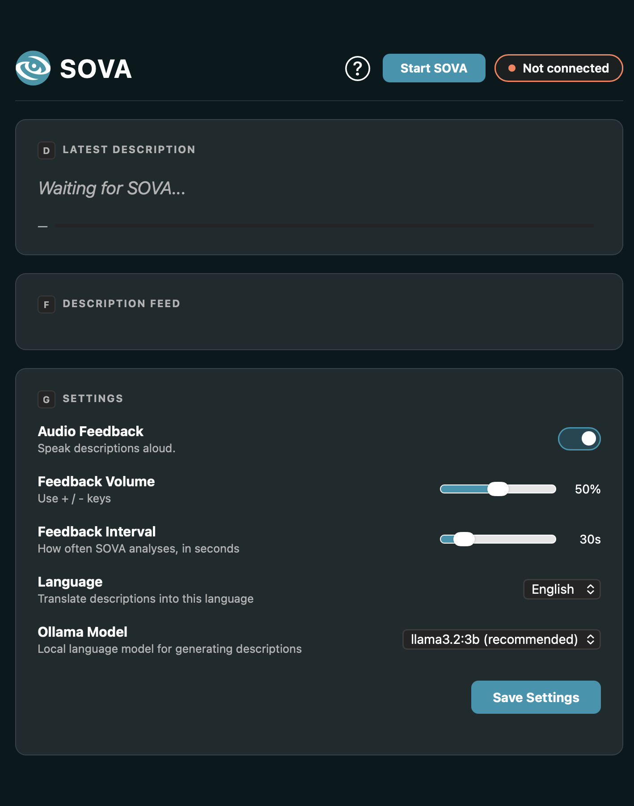

Figure 20: Dashboard (connected)

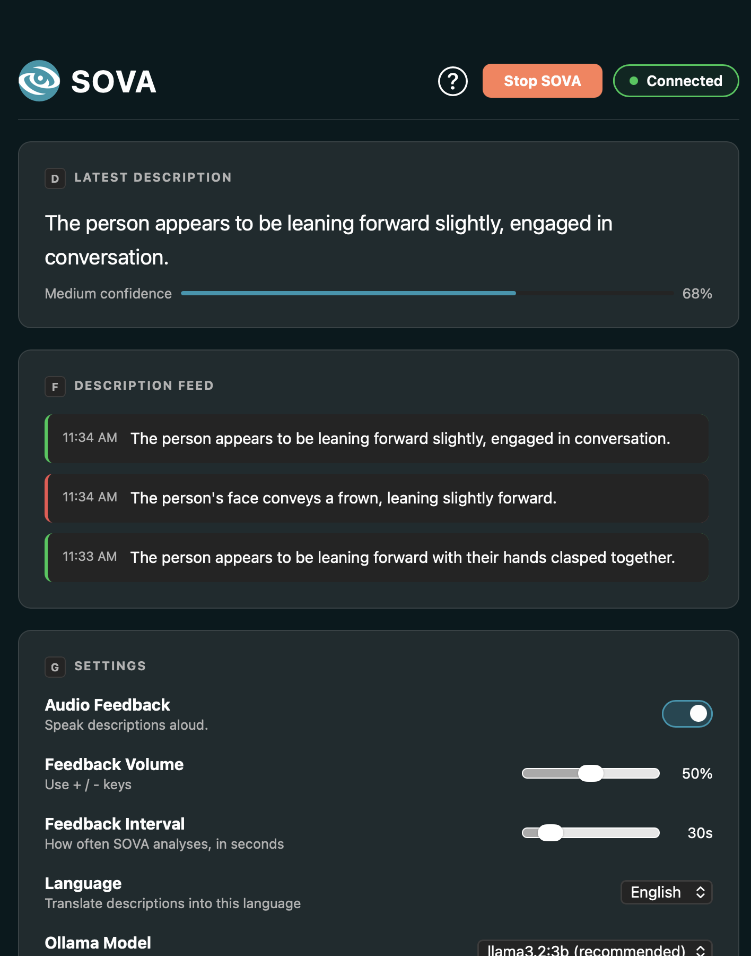

Figure 21: Help menu
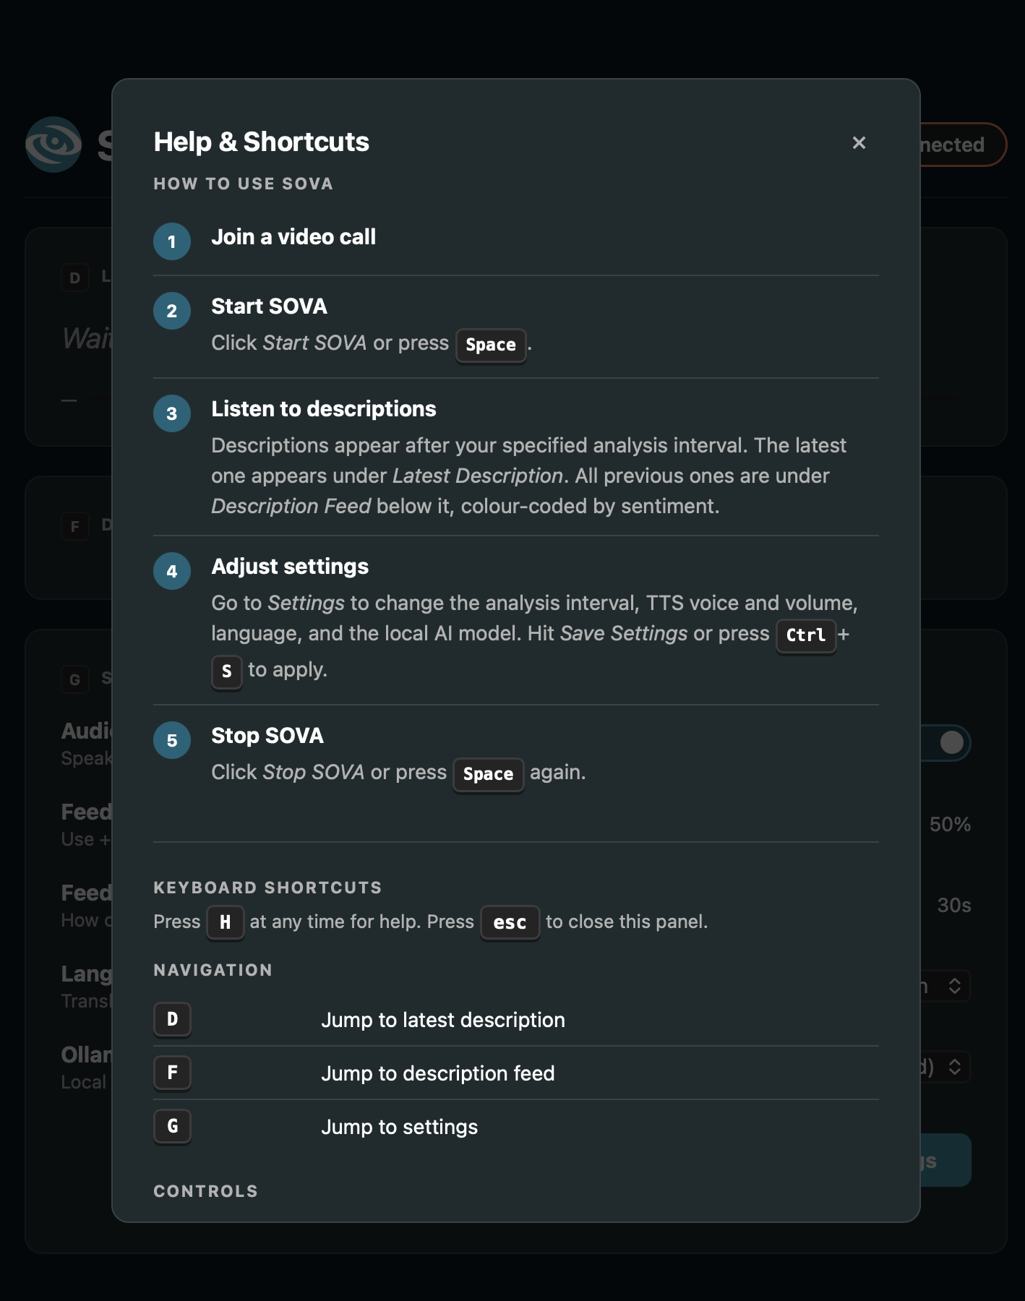 | 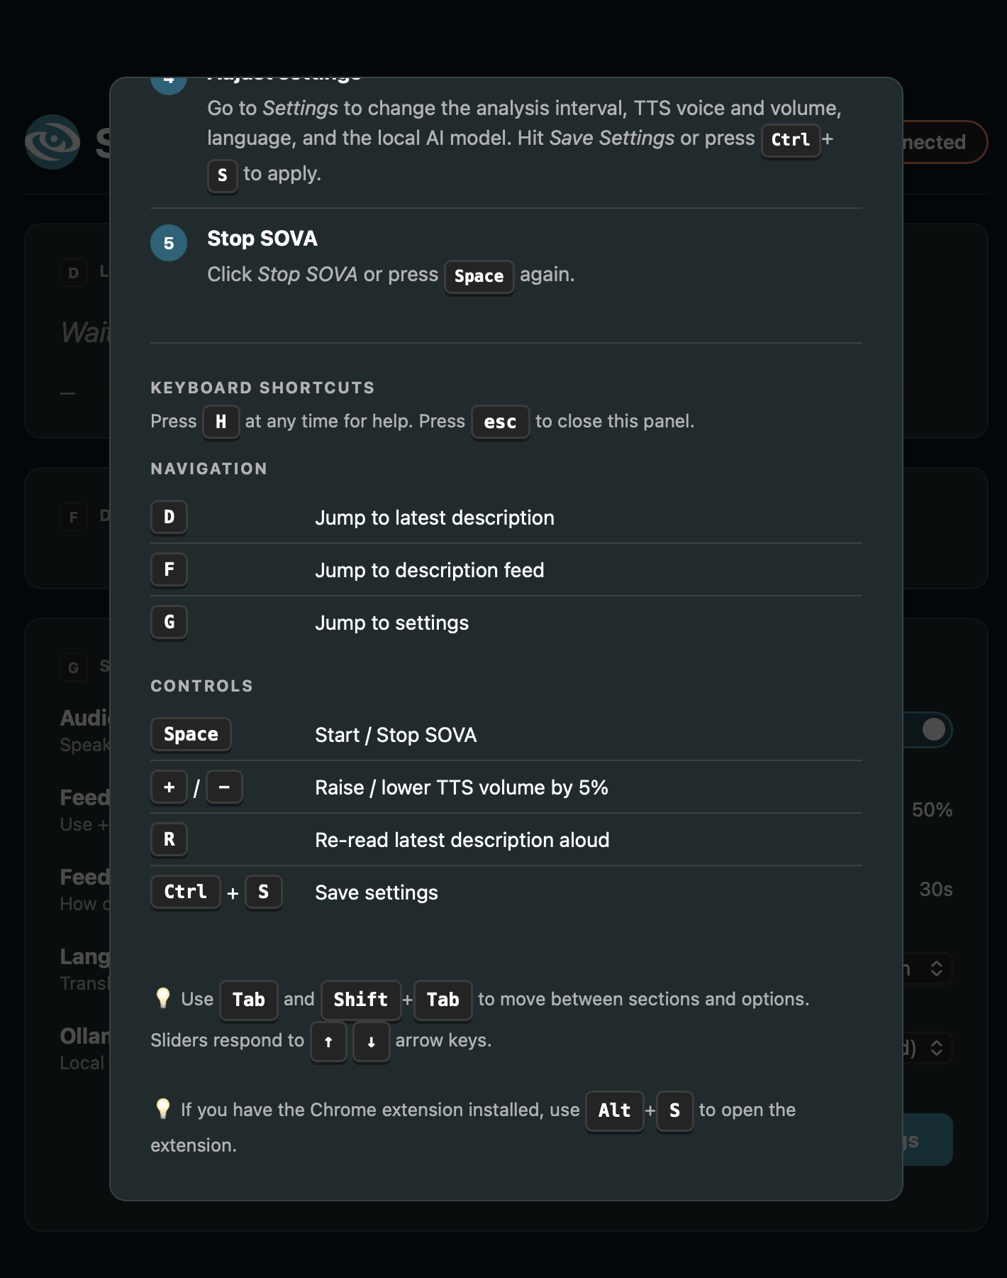

Chrome Extension Popup
Figure 22: Chrome extension (disconnected)  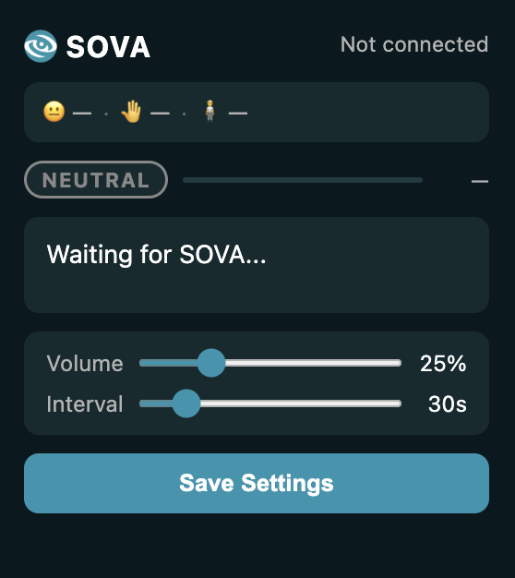 | Figure 23: Chrome extension (connected)  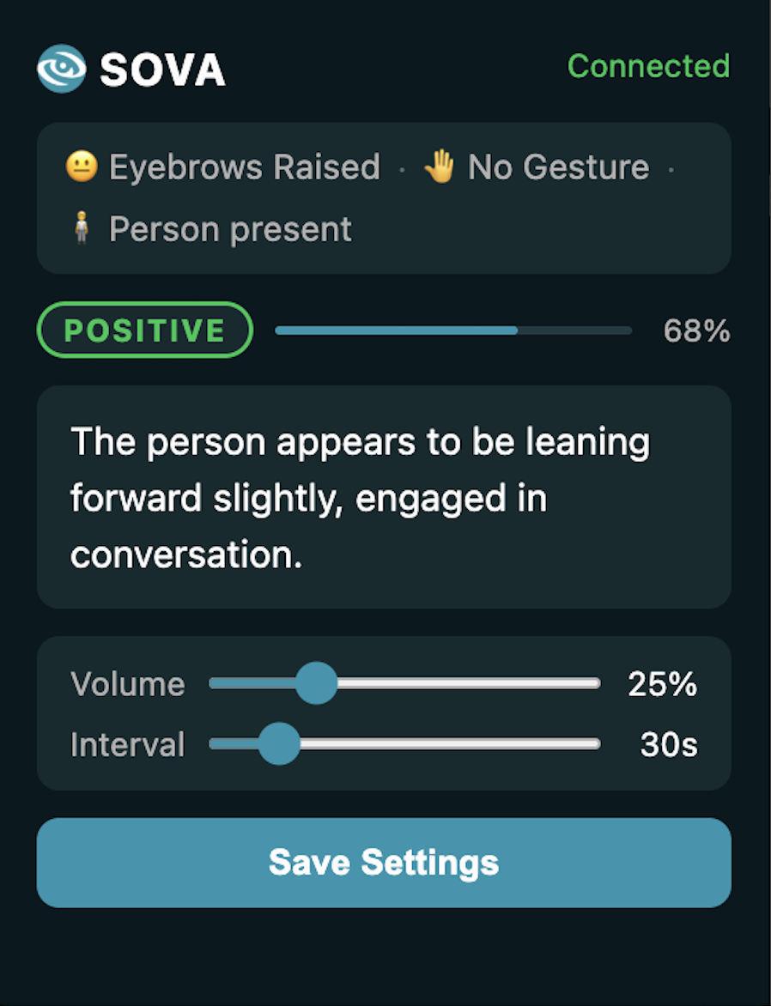

Google Meet Overlay

Figure 24: Google Meet overlay (disconnected)



Figure 25: Google Meet overlay (connected)


Figure 26: Google Meet overlay (connected with results)

Conclusion

Summary of Work
The SOVA system successfully provides an AI-driven accessibility solution that improves video conferencing experiences for visually challenged users. By combining computer vision, audio processing, and natural language generation, the system can interpret nonverbal cues and translate them into relevant real-time audio feedback. The project demonstrates the practical application of different AI technologies collaborating within a unified system, resulting in a functional and significant solution to real-world communication challenges.

Objectives Revisited
The system successfully meets its intended objectives by enabling accurate detection of facial expressions, gestures, and body language, along with real-time audio transcription and sentiment analysis. It also generates concise and context-aware descriptions and delivers accessible feedback through text-to-speech. Furthermore, the system demonstrates effective integration within video conferencing environments. These outcomes confirm that SOVA enhances communication accessibility by providing meaningful insights beyond spoken content, contributing to a more inclusive and engaging user experience.

Limitations
Despite its successful implementation, several limitations were identified, such as:
- The detection accuracy may vary under poor lighting or low-quality video input.
- Limited capability to handle several participants concurrently.
- Performance is determined by the local device's processing capability.
- Currently, integration is primarily focused on Google Meet.

Future Improvements & Long-Term Vision
There are several opportunities to further enhance the system, such as:
- Integration with other platforms, like Zoom and Microsoft Teams.
- Enhanced multi-person detection and tracking abilities.
- Using more complex AI models or training a model from scratch to improve accuracy of detections and context awareness of descriptions specifically in online meeting settings.
- Introducing meeting summaries and interaction insights.
- Expansion of language support and personalization features

References
AbilityNet (2025). An introduction to screen readers | AbilityNet. [online] abilitynet.org.uk. Available at: https://abilitynet.org.uk/factsheets/introduction-screen-readers.
Be My Eyes (2019). Be My Eyes - Bringing sight to blind and low-vision people. [online] Bemyeyes.com. Available at: https://www.bemyeyes.com/.
D’Souza, J. (2025). Google Meet Statistics and Facts (2025). [online] Electro IQ. Available at: https://electroiq.com/stats/google-meet-statistics/.
Dost, B. (2021). How can we improve Microsoft’s ‘Seeing AI’ application? [online] Medium. Available at: https://bengisudost.medium.com/how-can-we-improve-microsofts-seeing-ai-application-4cb4b074e0d6.
Doush, I.A., Al-Jarrah, A., Alajarmeh, N. and Alnfiai, M. (2022). Learning features and accessibility limitations of video conferencing applications: are people with visual impairment left behind. Universal Access in the Information Society. doi:https://doi.org/10.1007/s10209-022-00917-4.
GeeksforGeeks (2019). What is OpenCV Library? [online] GeeksforGeeks. Available at: https://www.geeksforgeeks.org/computer-vision/opencv-overview/.
Google (2025). MediaPipe Solutions guide | Edge. [online] Google for Developers. Available at: https://ai.google.dev/edge/mediapipe/solutions/guide.
Hammadi, O.I., Abas, A.D. and Khaled Hammad Ayed (2019). Face recognition using deep learning methods a review. International Journal of Engineering & Technology, 7(4), pp.6181–6188. doi:https://doi.org/10.14419/ijet.v7i4.22375.
Hull, R. (2016). The Art of Nonverbal Communication in Practice. The Hearing Journal, [online] 69(5), p.22. doi:https://doi.org/10.1097/01.hj.0000483270.59643.cc.
IBM (2021). What is Computer Vision? [online] Ibm.com. Available at: https://www.ibm.com/think/topics/computer-vision.
Iqbal, M. (2024). Zoom Revenue and Usage Statistics (2020). [online] Business of Apps. Available at: https://www.businessofapps.com/data/zoom-statistics/.
Microsoft (n.d.). Seeing AI. [online] Microsoft Garage. Available at: https://www.microsoft.com/en-us/garage/wall-of-fame/seeing-ai/.
Perkins (2023). Using the Envision app with low vision. [online] Perkins School for the Blind. Available at: https://www.perkins.org/resource/using-the-envision-app-with-low-vision/.
Scrum.org (2020). What Is Scrum? [online] Scrum.org. Available at: https://www.scrum.org/resources/what-scrum-module.
Stryker, C. and Holdsworth, J. (2024). What is NLP (natural language processing)? [online] IBM. Available at: https://www.ibm.com/think/topics/natural-language-processing.
University of Texas (2020). How much of communication is nonverbal? [online] online.utpb.edu. Available at: https://online.utpb.edu/about-us/articles/communication/how-much-of-communication-is-nonverbal/.
World Health Organization (2023). Blindness and vision impairment. [online] world health organization. Available at: https://www.who.int/news-room/fact-sheets/detail/blindness-and-visual-impairment.

Appendices

Appendix A: Glossary
Acronym | Definition
API | Application Programming Interface
LLM | Large Language Model
NLP | Natural Language Processing
RACI | Responsible, Accountable, Consulted, Informed
STT | Speech-to-Text
TTS | Text-to-Speech
UI | User Interface
WCAG | Web Content Accessibility Guidelines
WS | WebSocket

Term | Definition
Confidence level/score | A numerical value between 0 and 1 indicating the model's certainty in a detection result
DistilBERT | A lightweight version of the BERT language model used for sentiment classification
Face/Hand/Pose landmarker | A MediaPipe model that detects and tracks facial, hand, and pose landmark coordinates
Flush | The act of processing all accumulated detection buffers to produce a single output result
Flush/Feedback/Capture interval | The time period after which accumulated detections are processed and a description is generated
Frame | A single image captured from a video stream
Google Meet Overlay | A UI element rendered on top of a Google Meet
MediaPipe | Google's framework for building multimodal machine learning pipelines
Non-verbal cues | Communication signals conveyed through facial expressions, gestures, and body language rather than speech
Ollama | A tool for running large language models locally on a user's machine
Participant | The person in the video call that the user is talking to
PyWebView | A Python library that creates a native desktop window rendering HTML/CSS/JavaScript content
Sentiment Analysis | The process of identifying the emotional tone of text as positive, negative, or neutral
WebSocket | A communication protocol providing full-duplex channels over a single connection

Appendix B: Github
See Github Repository
All deliverables (aside from the software itself) are located in the /docs directory, including the poster, report, and a document containing links to the website and YouTube video.

Appendix C: Deliverables Links
See SOVA Website
See SOVA YouTube Video

Appendix D: Preliminary & Final Figma Prototypes
See Final Figma Prototype
See Preliminary Figma Prototype

Appendix E: Report Work Distribution
Member | Contribution
Aagna Samhita | System Design
Anelle Khare | Planning & Feasibility
Samia Khan | Introduction, Testing, Conclusion
Sandra Jose | System Requirements
Sanura Castellino | Testing
Sara Hayel | System Requirements
Sofia Francisco | System Design, Implementation, Product Demo

